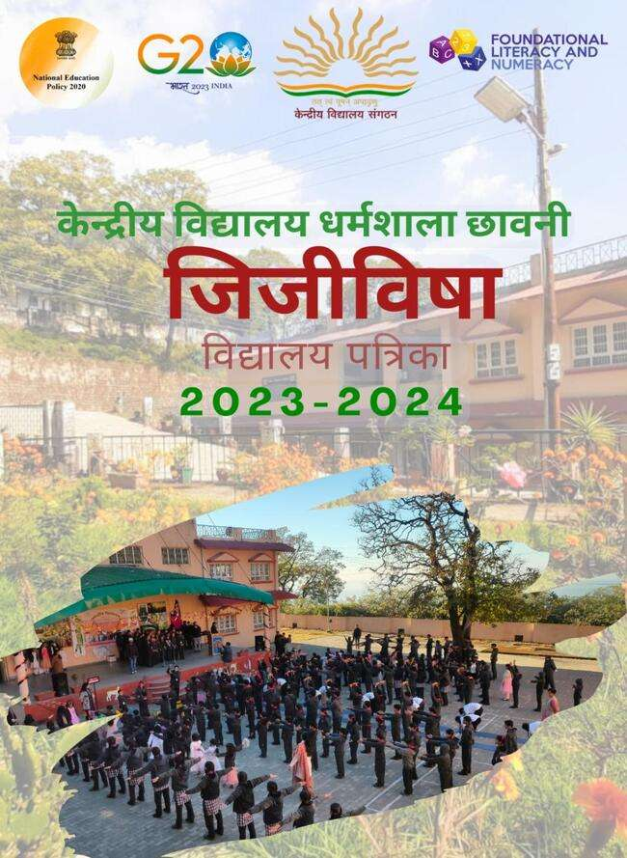

विद्यालय पत्रिका 2023-24
संपादक - मंडल

प्राचार्य की कलम से ₋₋₋₋₋₋₋₋

प्राचायय
केन्द्रीय विद्यालय

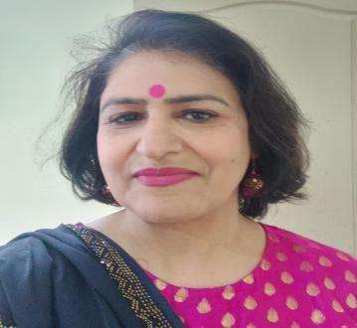
From the Editor’s Desk…………..

We are delighted to present to you the E-magazine for the academic year 2023-24. The year is replete with a lot of upheavals and testing times as far as school activities are concerned. But we are a satisfied lot for having achieved most of our goals with a great sense of pride. This platform is for the young budding minds, so, kept them busy through various activities organized by their mentors and the response from the young go-getters was awesome.

Through this E-magazine we are pleased and honoured to share with you the messages from the stalwarts and luminaries of KVS and the honourable Chairman. You will also discover a wealth of contribution from students and faculty in the form of inspirational thoughts as well as useful and interesting write-ups. It is not just the text but the splendour and plethora of pictures and images that will woo you to the number of activities, celebrations and enriching events that unfolded during the academic year.

The editorial board extends its heartfelt gratitude to our Erudite Principal Madam, for her foresight and guidance in bringing out this beautiful publication.

Special appreciation to the assiduous team of Student Editors for their commendable compilation, creativity and technical support. I also extend my genuine gratitude to all the staff of the Vidyalaya, especially the language departments for their invaluable support. I would be failing in my duty if I did not mention students and staff who have endeavoured to the hilt and contributed their might to ensure that this first edition of E-magazine ‘INSPIRA’ remains vibrant and inspiring.

Hope you enjoy reading this as much as we enjoyed in preparing and serving it to you
Thanks, and best wishes.

Anita Kohli
PGT English

विद्यालय प्रबंधन समिति 2023-24

क्र.सं. | पद | सदस्य
1 | अध्यक्ष | Brig KVP Singh Sambyal, CDR 33MTN, BDE.
2 | अध्यक्ष द्वारा नामित | Lt Col Priansh Gill, SO-2 (Education) 33MTN BDE
3 | ख्याति प्राप्त शिक्षाविद | Dr. Vinod Kumar Sharma  Associate Prof.Dept. of Geog.  Govt. PG. College Dharamshala
4 | ख्याति प्राप्त शिक्षाविद | Dr. Vikram Vats, Associate Prof.  Dept. of Phy. Govt. PG. College Dharamshala
5 | संस्कृति के क्षेत्र में ख्याति प्राप्त व्यक्ति | Dr. Y.K. Dogra  Ex Professor, PG College Dharamshala
6 | अभिभावक सदस्य | Mr Anuj Kumar; F/O Master Vaibhav  Class –VI
7 | अभिभावक सदस्य | Mrs. Ranju Bala M/O Master Raghav  Class-XI(Science)
8 | ख्याति प्राप्त स्थानीय चिकित्सक | Dr. Anuradha Balgaria, DPO, Office of CMO, Kangra at Dharamshala
9 | अनुसूचित जाति/जनजाति सदस्य | Dr. Anil, Medical Officer, Regional Health and Family Welfare Training Centre, Chheb, Kangra
10 | अध्यापक सदस्य | Mrs. Rita Kumari (PGT BIO) KV Dharamshala Cantt.
11 | प्राचार्या/सचिव सदस्य | Mrs. Pushpa Sharma, Principal  KV Dharamshala
12 | सह-योजित सदस्य | Maj. Nikhil, EME, Workshop,839
13 | अध्यक्ष के.स.क.क.स. समिति | Mr. Kura Ram, Deputy Director, Audit & Accounts, Pathankot
14 | तकनिकी सदस्य | Mrs. Vaishali Yadav, IDSE, AEE(Civil)

कर्मचारियों की सूची
क्र.सं. | नाम | पद
1 | Mrs. Pushpa Sharma | Principal
2 | Mrs. Anita Kohli | PGT(Eng.)
3 | Mr. Suman | PGT (Eco)
4 | Mr. Ramesh Kumar | PGT(CS)
5 | Dr. Rajander Singh | PGT(Hindi)
6 | Mrs. Rita Kumari | PGT (Bio)
7 | Mrs. Doli | PGT(Comm.)
8 | Mr. Anuj Kumar | PGT (Maths)
9 | Ms. Kiran Kumari | PGT (Chem)
10 | Mrs. Anjana | PGT(Phy)
11 | Mrs. Priyanka Sharma | TGT (Maths)
12 | Mr. Vipul | TGT (S.Sc)
13 | Mr. Chaman Singh | TGT (PET)
14 | Mr. Swarn Singh | TGT (Eng)
15 | Mr. Tarkeshwar Prasad Tarun | Librarian
16 | Mrs. Jyoti | TGT (SKT)
17 | Mr. Vikas Azad | Computer Instructor
18 | Mr. Kapil Dev | PRT
19 | Mrs. Rajnu Bala | PRT
20 | Mrs. Sheelu | PRT
21 | Mrs. Manjuli | PRT
22 | Mrs. Sapna Majotra | PRT (Music)
23 | Mrs. Reetu | PRT
24 | Mrs. Ashima | PRT
25 | Mrs. Shweta | Special Educator
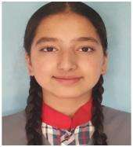
Sometimes I wonder, how just 12 years back we could not hold a pen, read, or write or do any of the complex activities that we are capable of doing now.
Once a KVian, always a KVian!
From the Head Girl’s Pen

I, like many other students have had the best and the worst experiences in these years at School.
We have come a long way from learning how to close our tiffin boxes in the first standard to learning how to protect our tiffin boxes from our friends before lunch!
I joined Kendriya Vidyalaya Dharamshala Cantt in 1st standard and I clearly remember my first day of school here... Apart from acclimatizing myself to the new surroundings and people,
The love I received from all my teachers and friends was heartwarming. I thank them all, especially honorable Principal ma'am, for having provided us with such wonderful experiences and knowledge. I am immensely grateful to my teachers and parents for nurturing me and making me capable enough to lead my school.
It is here that my dream of being the head girl came true and with it came responsibilities that helped me identify and explore new potentials in me and serve the institution better. I would like to thank all council members and each student for their continuous support.
School life is one of the longest and most dramatic stages of life. School days really are the best days of our lives, and I have only good memories of my school days. For me, these days are like an invaluable treasure.
I am sure the class of 2022-23 will make this prestigious institution proud. All we have to do is keep our head and josh high!

Shaina Chouhan Ghantoo
School Captain-2022-23

THE WONDER YEARS OF SCHOOL
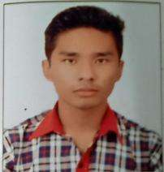

I would like to start by thanking not only Principal but teachers and other schools members also who worked extremely hard each year for us This year made my high school year very memorable not because it’s was my last year in this school but because everyone had a impact on me. Last year though we all were isolated, but we manage to grow closer and closer to each other. I cherish each moment of my school life that I spend in KV Dharamshala cantt. Teachers provided their best and everyone worked so hard each year to support us through the exam time.
Over the years Principal mam and teachers taught us so much, specifically to believe in yourself even if you felt like you are not going to achieve something. I always remembered the life lessons they taught us and will be grateful forever. And how can I forget about Mrs. Anita, Mr. Ramesh, Mr. Anuj and many more teachers who support each and every student no matter how bad the situation was.
It seems impossible for me to sum up all the past experiences that I learned from this school. However, one message I would like to pass on, is to first believe in yourself even u have failed many times because failure is just a lesson you learned from your mistake. In short, I would like to conclude it as don’t be afraid of failures but be terrified of regrets. When leaving the school, you realize that people you have been working from years leave to do something different from yourself, everyone has different skill, talent and qualities. Lastly on behalf of every leaver I would like to thank everyone in the school for giving some of the remarkable memories. It was my best years shared with my friends and spend in this school.

Narayan Rana
School Captain (2022- 23)

STALLWARTS
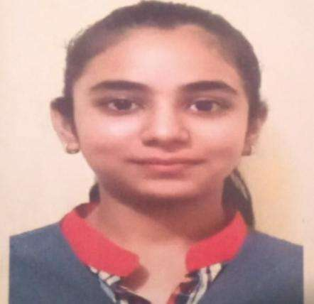

Topper of Gurugram Region & KV Dharamshala
Savi Rustagi (XII B) 97.2%

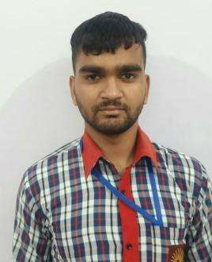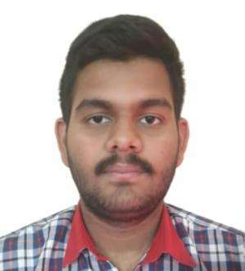
SHIVANSH Topper Class X (82.4%)
RONIT BALOURIA (XII A)
Topper Science Stream (91.6%)

पाठ्र् सहगामी गतिविधियों की एक झलक

SHUBHORAM DIVAS
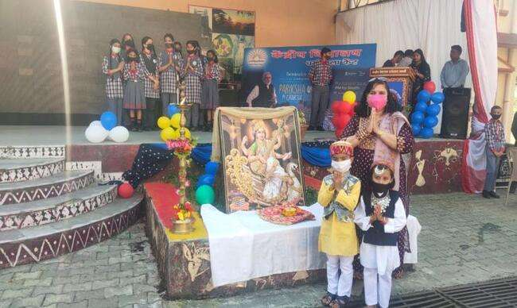

INVESTITURE CEREMONY

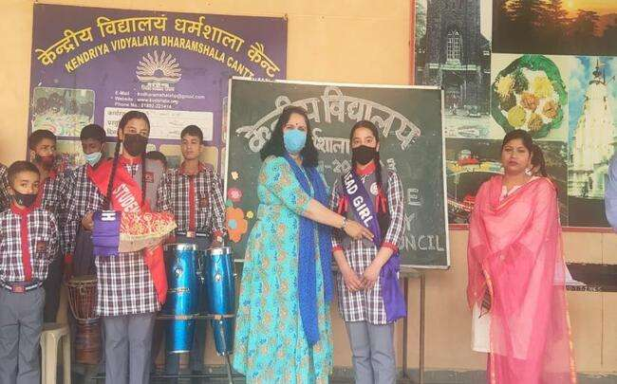
VIDYA PARVESH

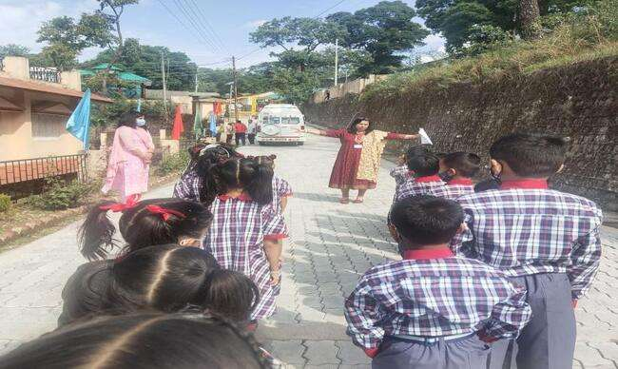

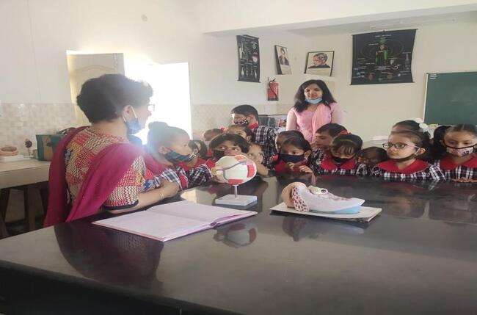
ADMISSION LOTTERY

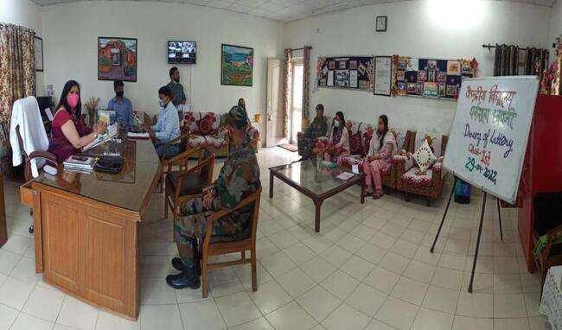

ATL COMMUNITY DAY

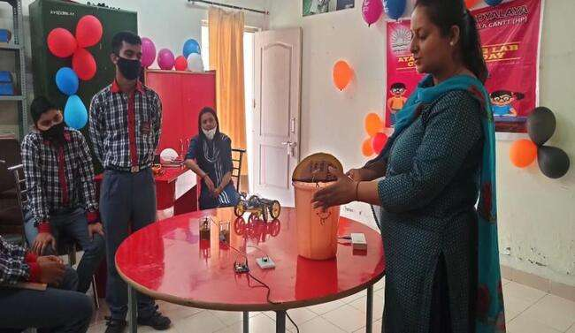
DWITYA SWOPAN JAANCH DIVAS

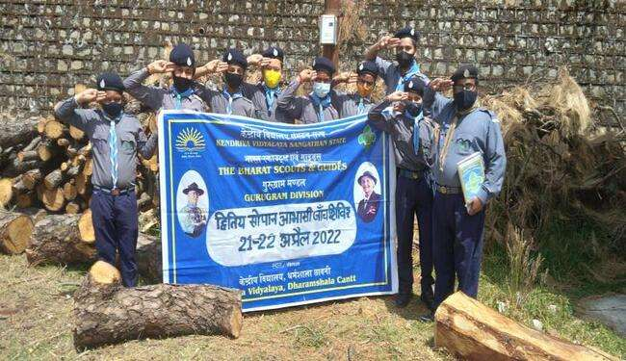

PRE-RASHTRAPATI TESTING CAMP

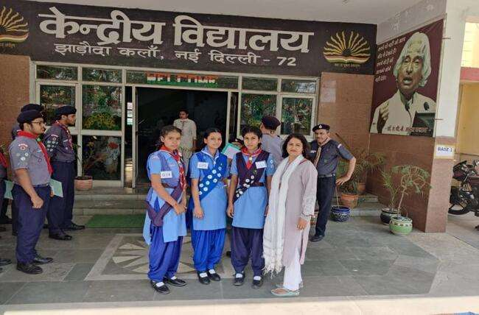
ROUTES TO ROOTS

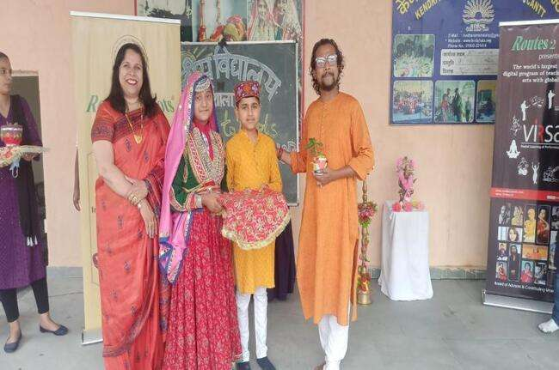

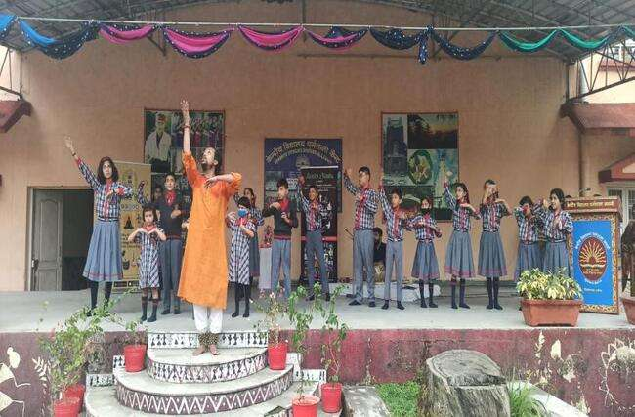
DRUG ABUSE GUIDANCE & COUNSELLING SESSION

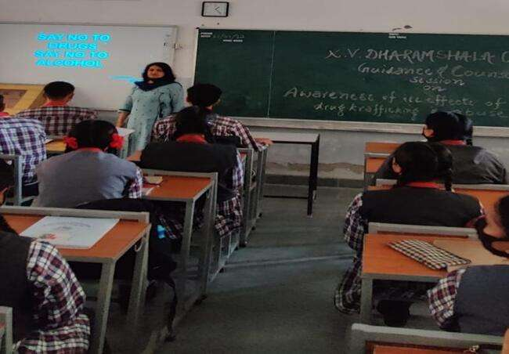

INTERNATIONAL TABLE TENNIS MATCH

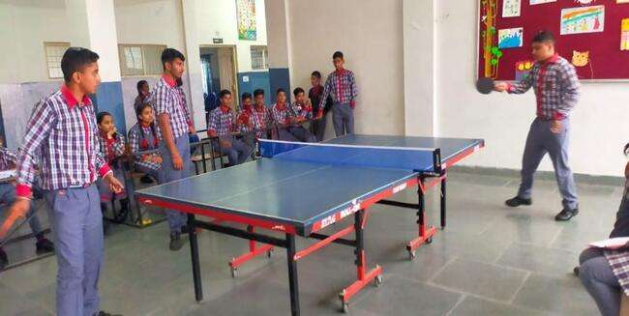
VACCINATION DRIVE

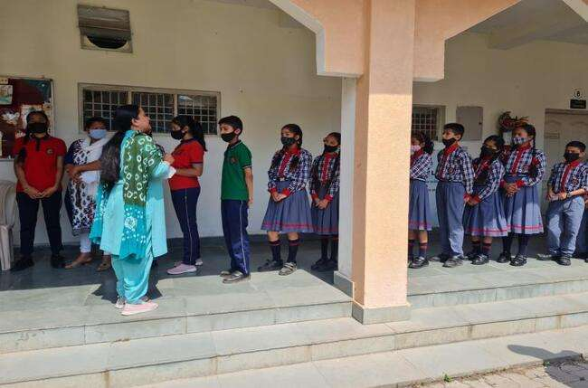

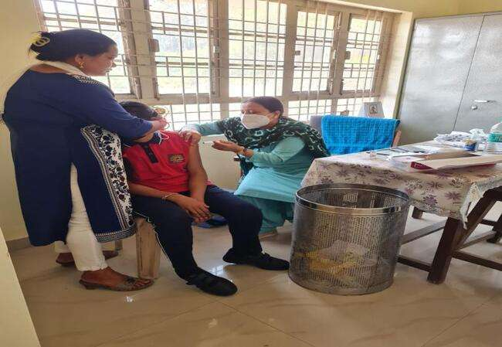

INTERNATINAL YOGA DIWAS (21-06-22)

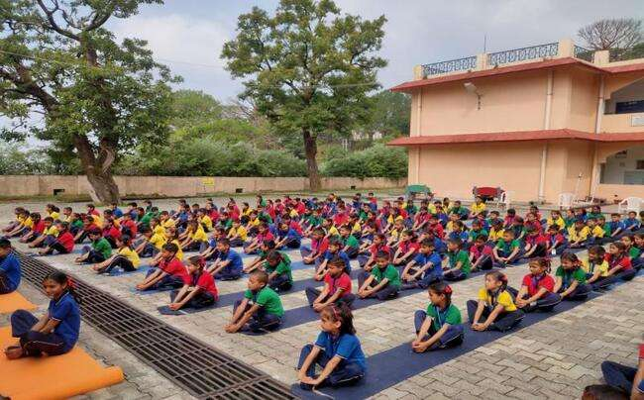
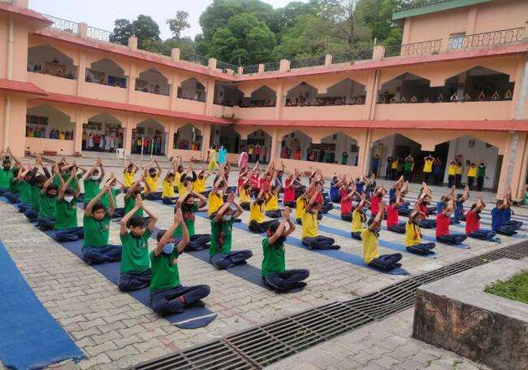

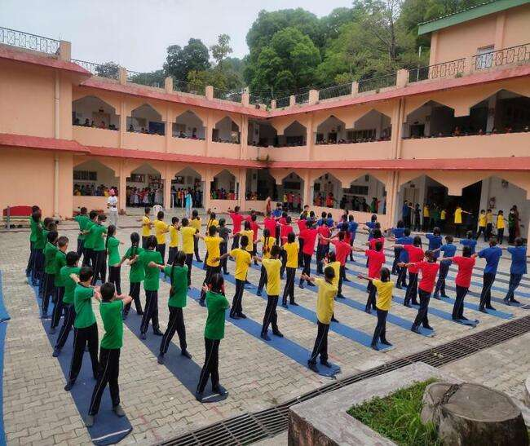
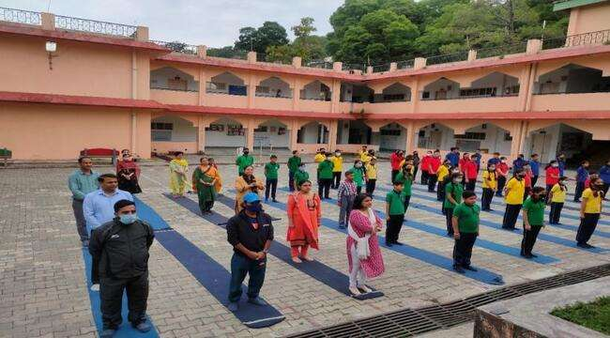

DWITYA SWOPAN SHIVIR

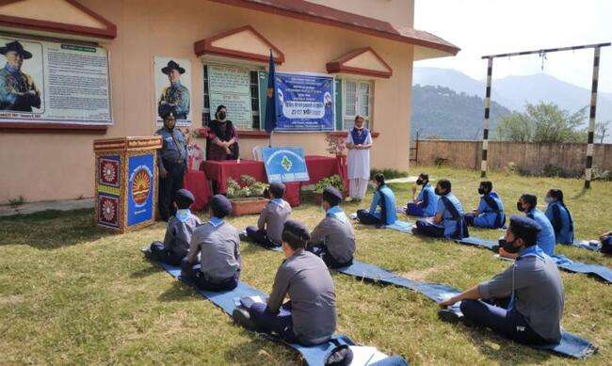

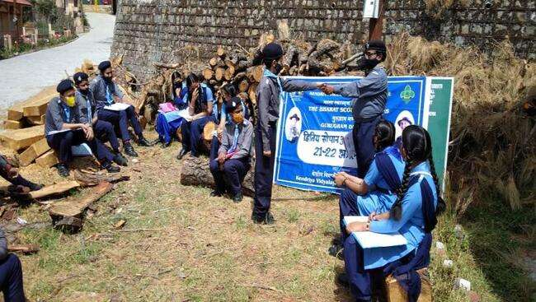
HISTORICAL PLACE VISIT

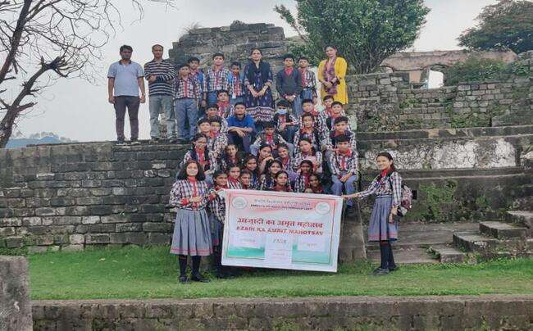

VAN MAHOTSAV (15-07-22)

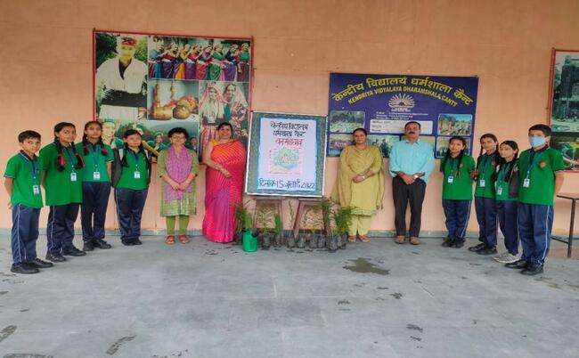
VMC & PTA (25-07-22)

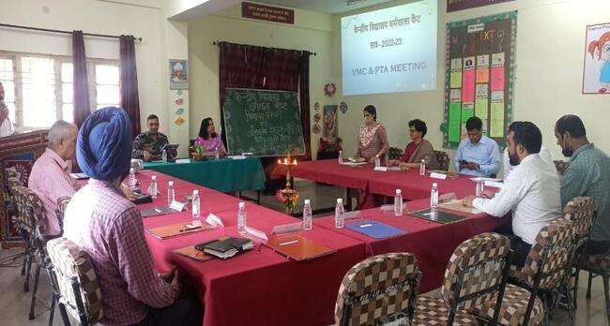

SUBJECT COMMITTEE MEETING (31-07-22)

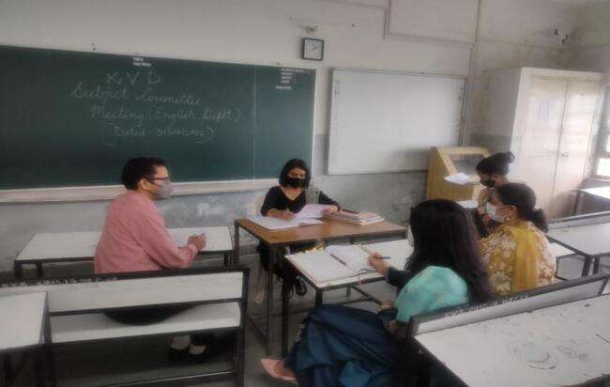

CLUB ACTIVITIES

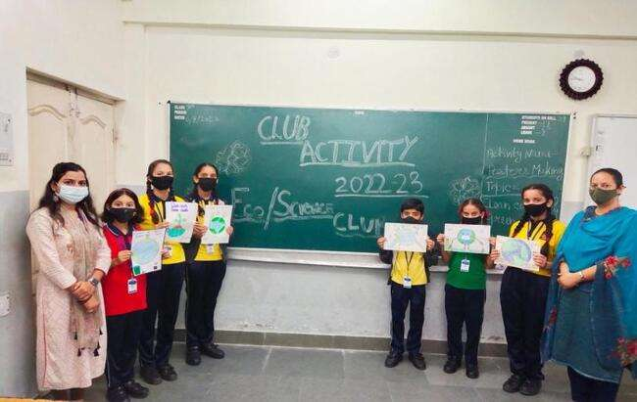

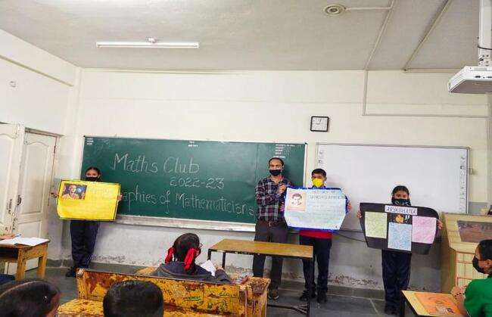
FELICITATION DAY

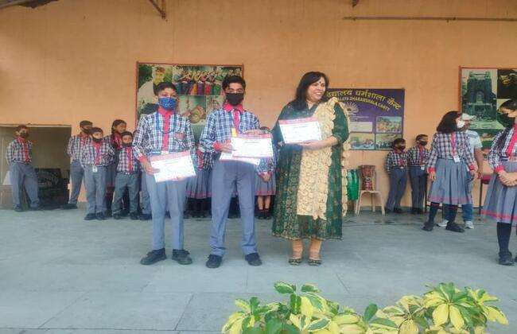

SADBHAWNA DIVAS (22-08-22)

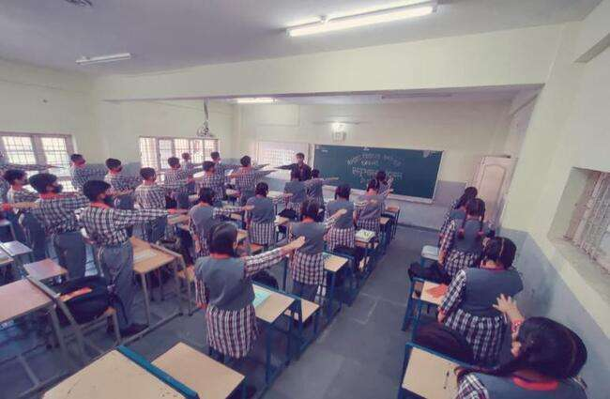

SANSKRIT WEEK INAUGRATION (5-8-22)

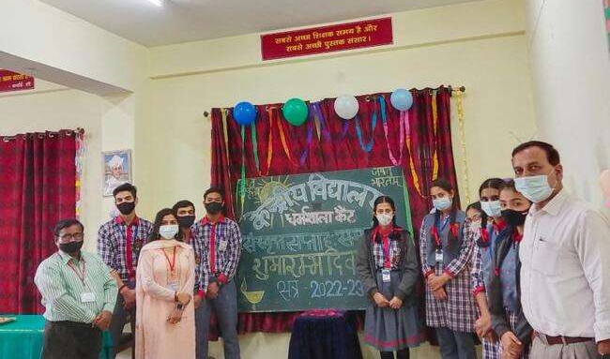

SWACHATA PAKHWARA (26-8-22)

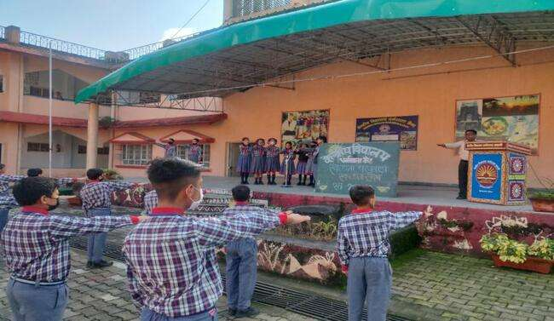

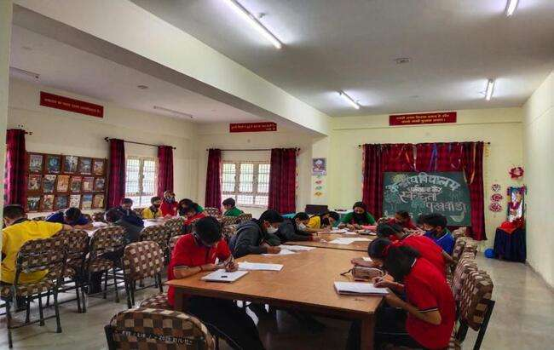

BIS WORKSHOP (7-9-22)

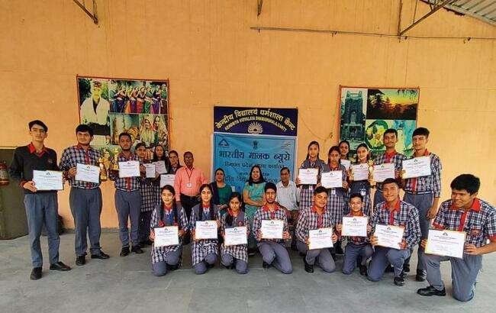

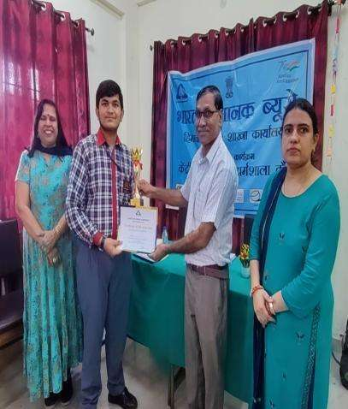

RSM GIRLS ATHLETICS REGIONAL LEVELMEET

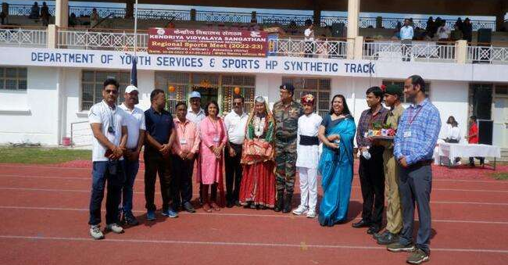

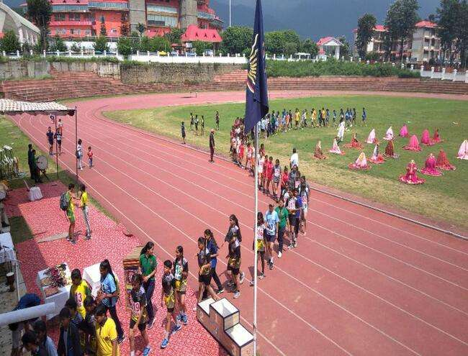
RASHTRIYA EKTA PARV

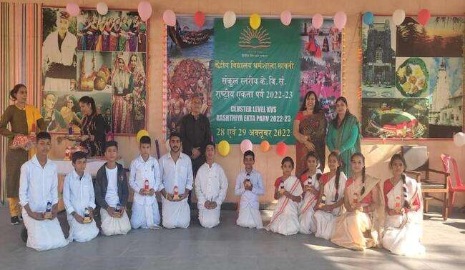

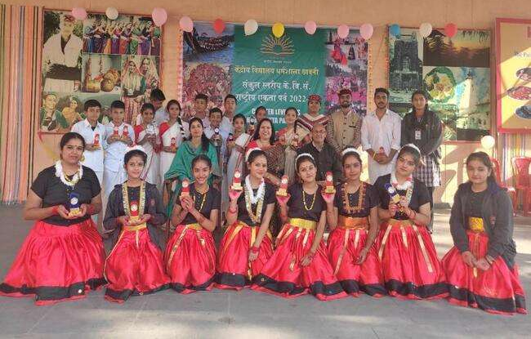

SCHOOL LEVEL NCSC (27-10-22)

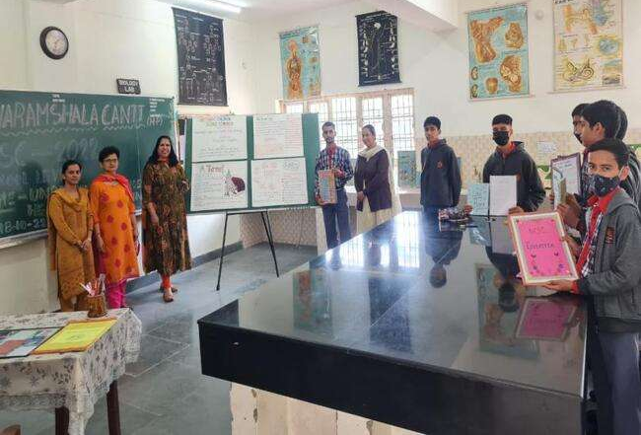

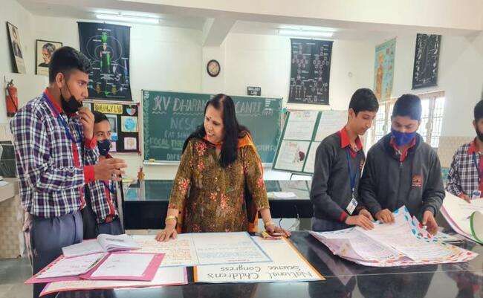

ANNUAL SPORTS DAY

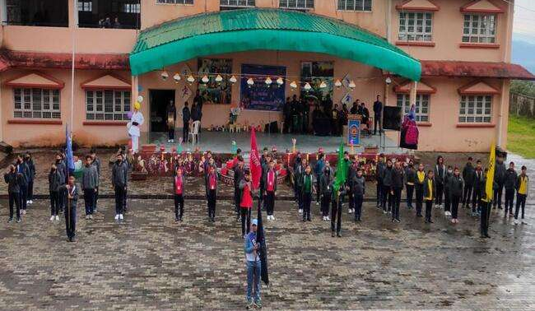
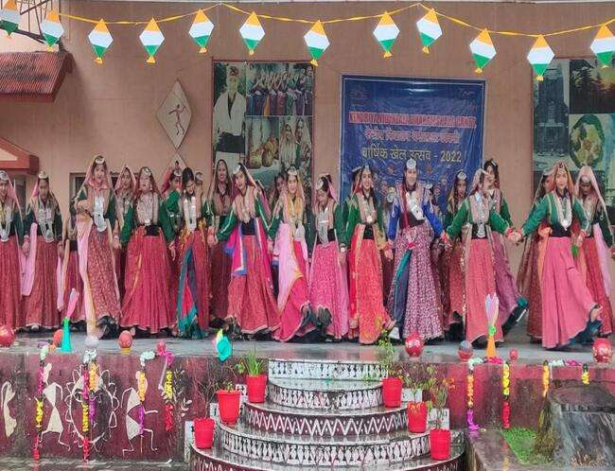

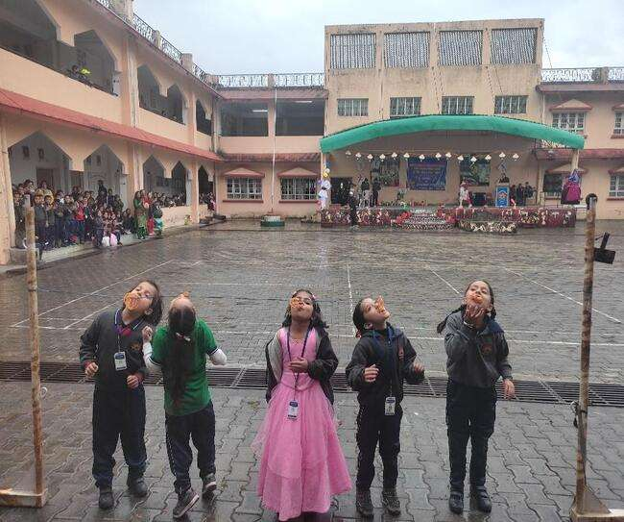

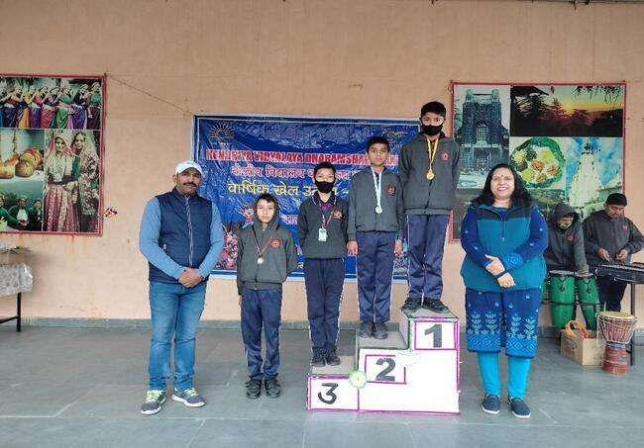

CONSTITUTION DAY

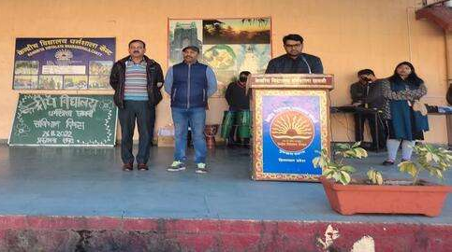

ANNUAL INSPECTION

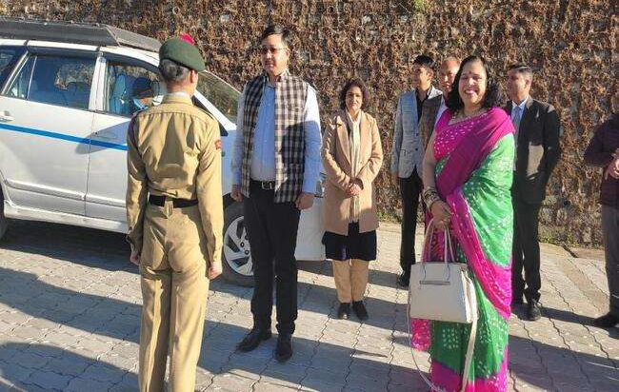

CLUB ACTIVITIES

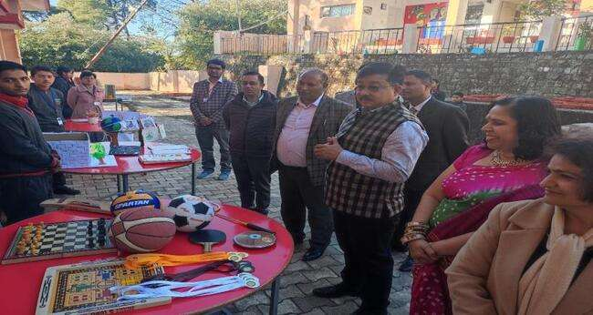

BUBUL SHOW

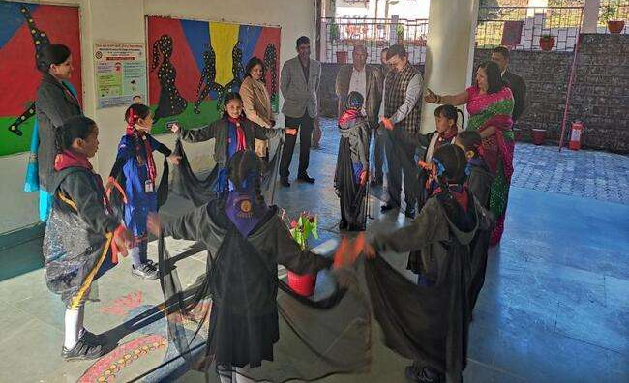

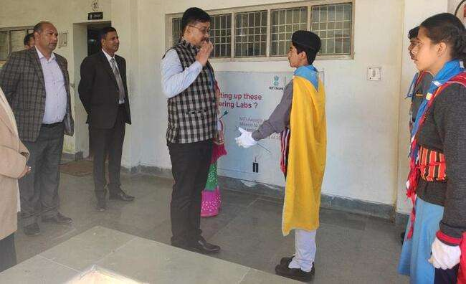
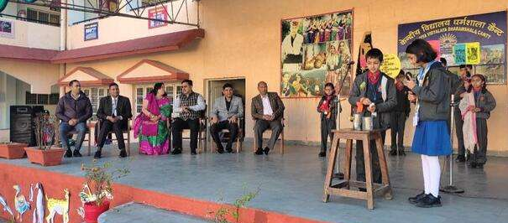
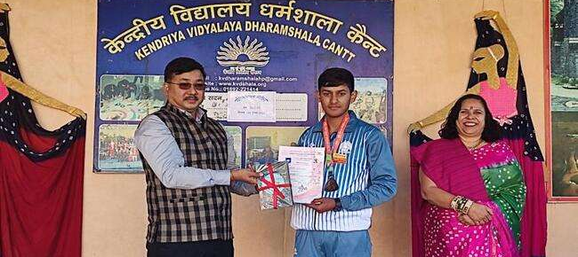

ENVIRONMENT AWARENESS WEEK under EBSB
(8TH March 2022 to 18TH August,2022)
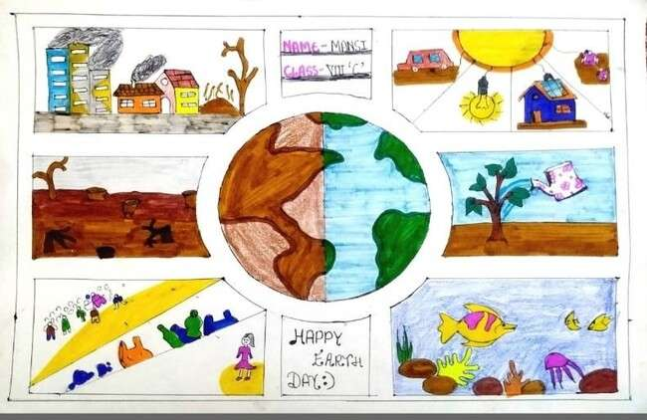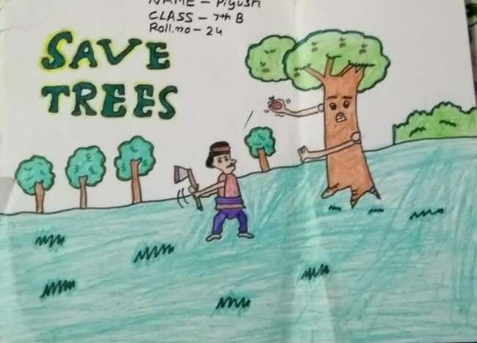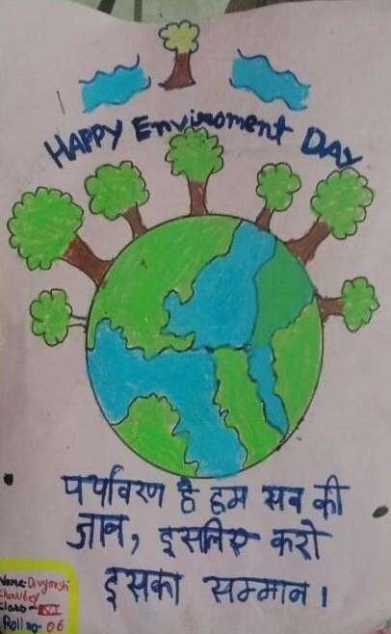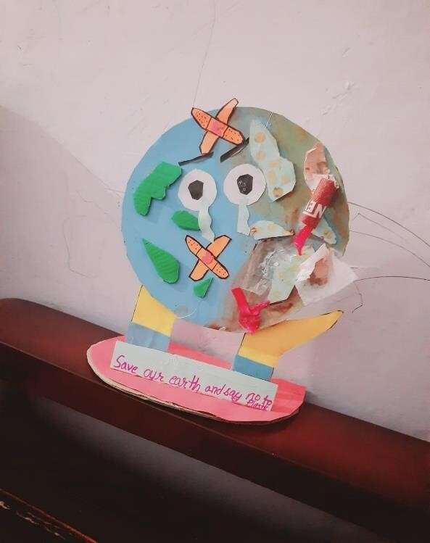

ELIMINATION OF SINGLE USE OF PLASTIC under AKAM
(4th to 10th October,2022)
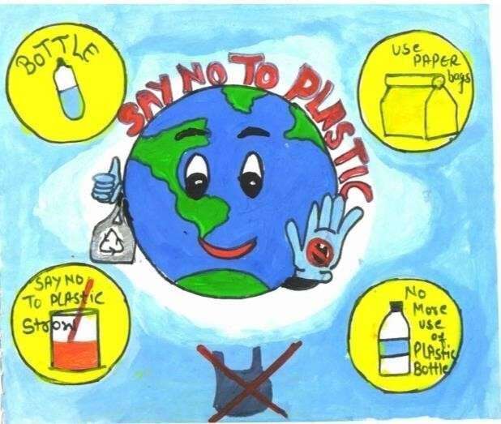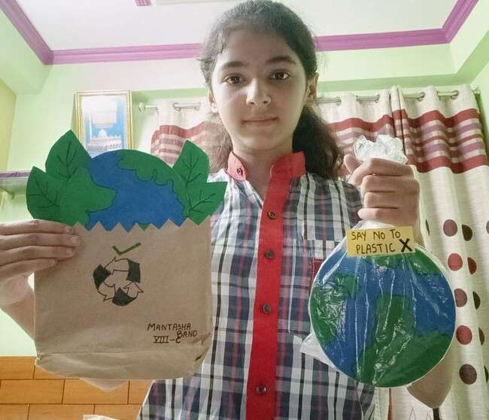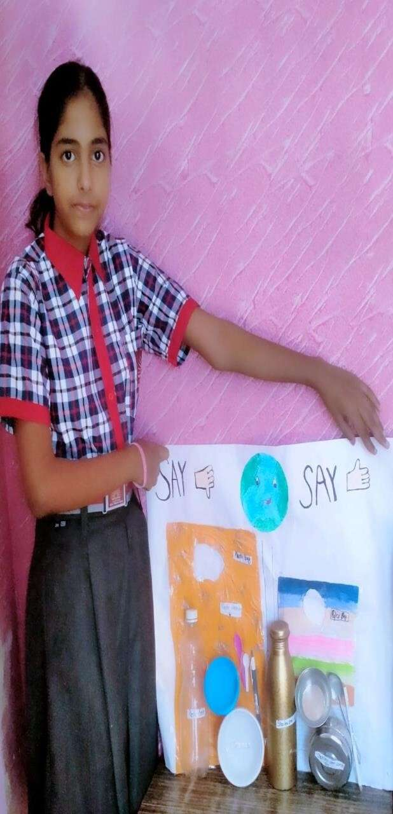

VIGILANCE AWARENESS WEEK under AKAM 26th October to 1st November, 2022
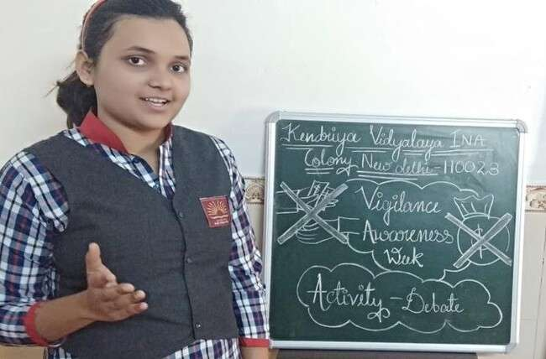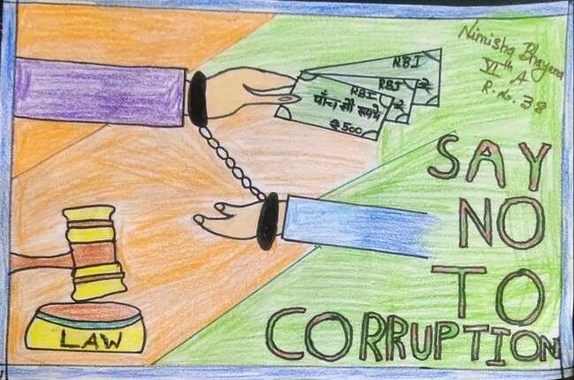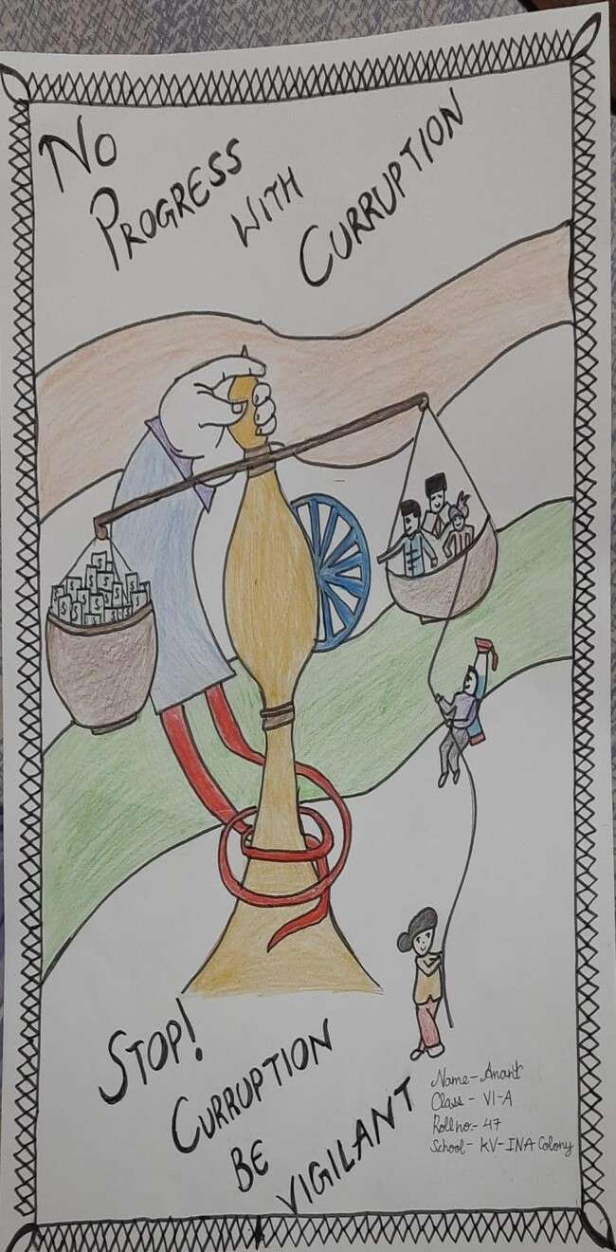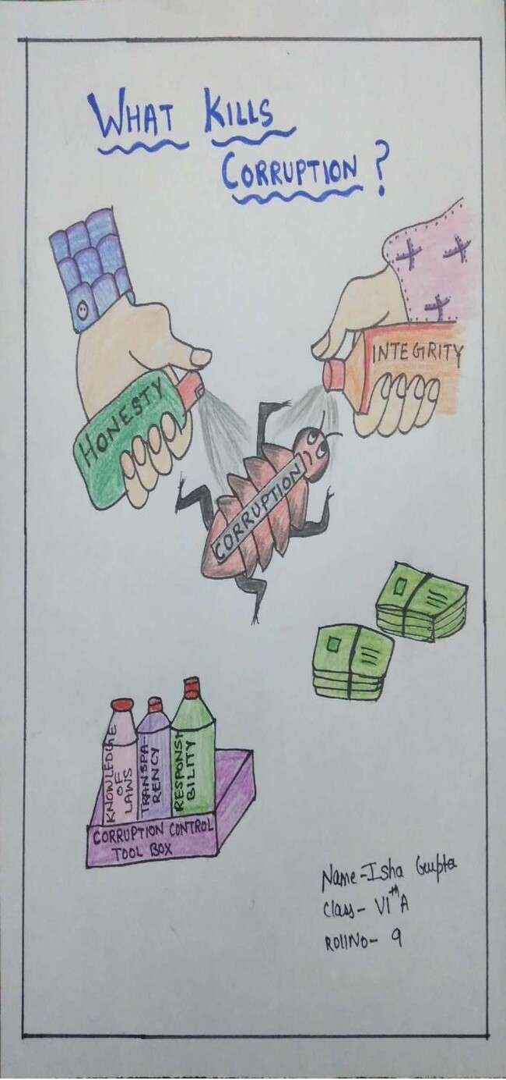

Rashtriya Ekta Diwas (National Unity Day)

29.10.2022

ACTIVITIES UNDER AZADI KA AMRIT MAHOTSAV

ICONIC WEEK 17th TO 21th January, 2022

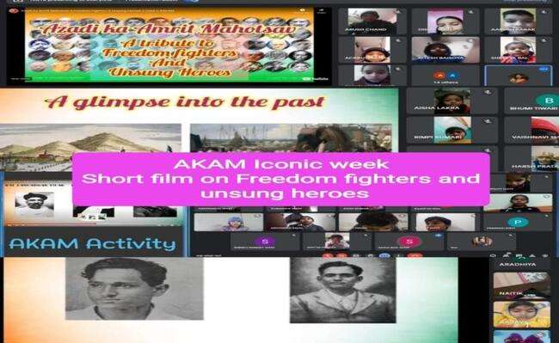

CELEBERATION OF 75th REPUBLIC DAY

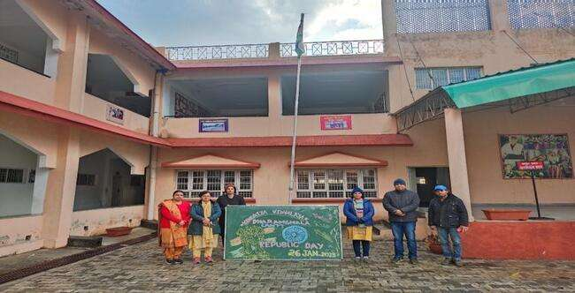

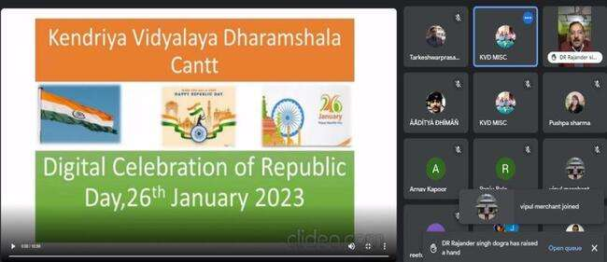

SLOGAN WRITING ON G20

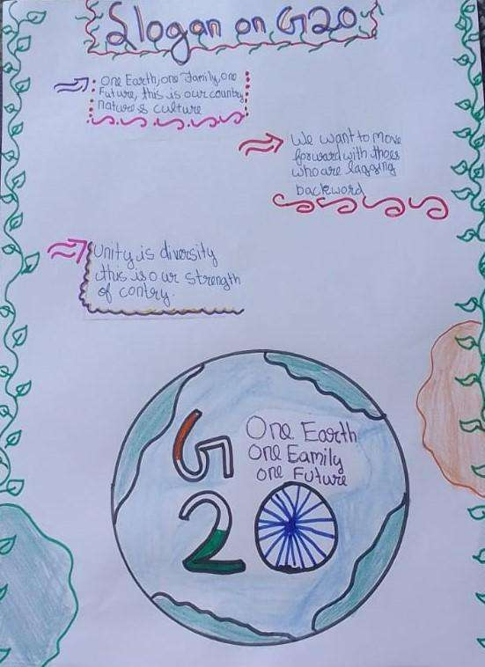

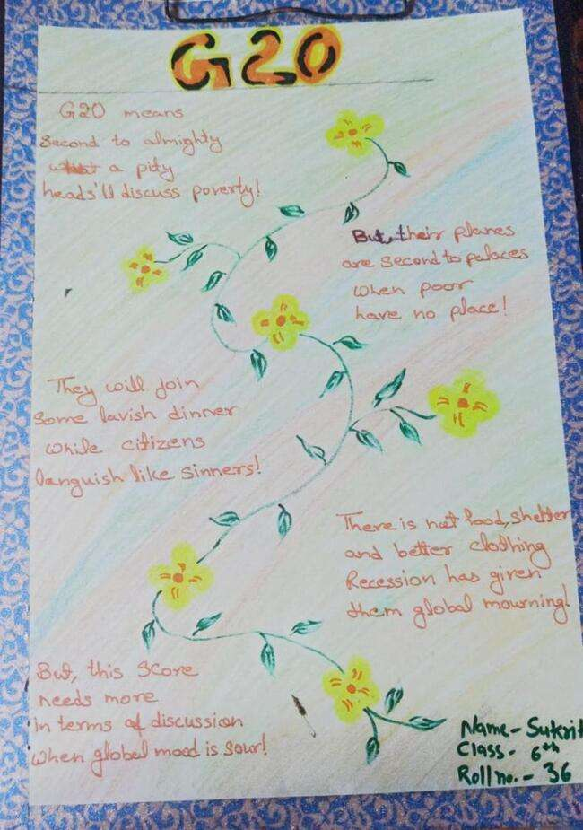

हिंदी विभाग

संपादकीय

हिमाच्छादित श्वेत शिखर हैं देवदारू करते श्रृंगार , अज्ञात चितेरे तुमको जाना देखी जब यह धौलाधार

धवल धार के नैसर्गिक सौंदर्य को देखकर उससे प्रभावित हुए बिना कौन रह सकता है । कहा भी गया है कि साहित्य में हमारा परिवेश प्रतिबिंबित होता है। इस क्षेत्र के अनुपम सौंदर्य से प्रभावित होकर हमारे विद्यालय के नन्हे सुकुमार रचनाकारों ने भी अपने हृदय में छिपे भावों को वाणी देकर शब्दों में अभिव्यक्त करने का सार्थक एवं सराहनीय प्रयास किया है । रचनाओं को प्रकाशित करने के पीछे छात्रों को प्रोत्साहित करने की भावना रही है । काव्यात्मक त्रुटियों हेतु वे क्षम्य हैं। हमें छात्रों की बहुत सी रचनाएं प्राप्त हुईं । जिन छात्रों की रचनाएं इस पत्रिका में प्रकाशित हुई हैं निसंदेह वे विद्यालय के अन्य छात्रों के लिए प्रेरणा का स्रोत होंगी ।

हृदयी शुभकामनाओं के साथ
राजेंद्र सिंह
स्नातकोत्तर अध्यापक हिंदी

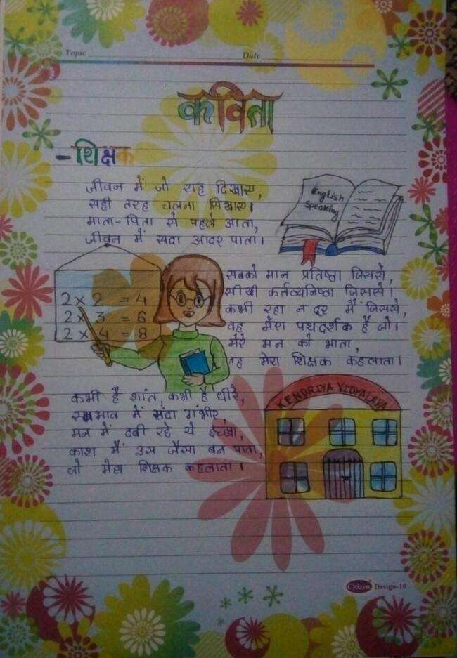

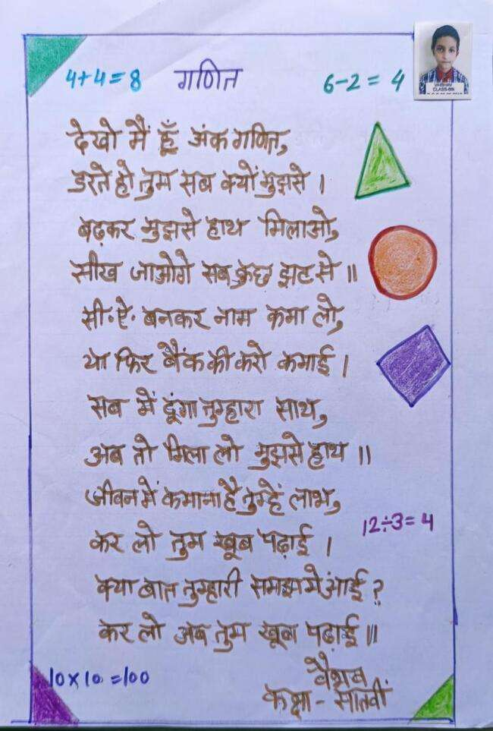

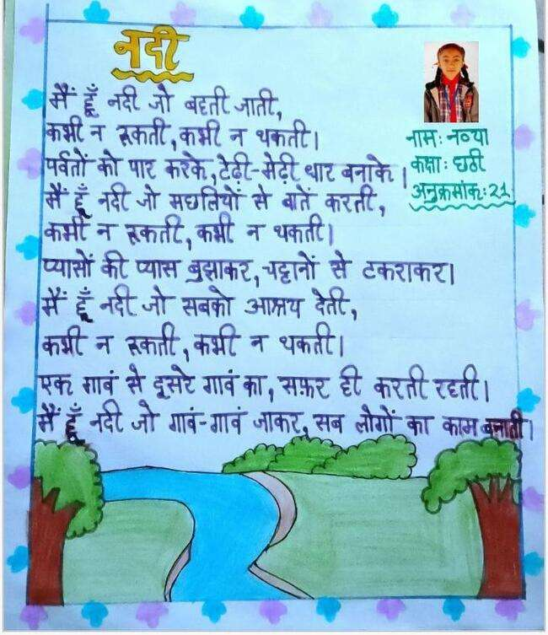

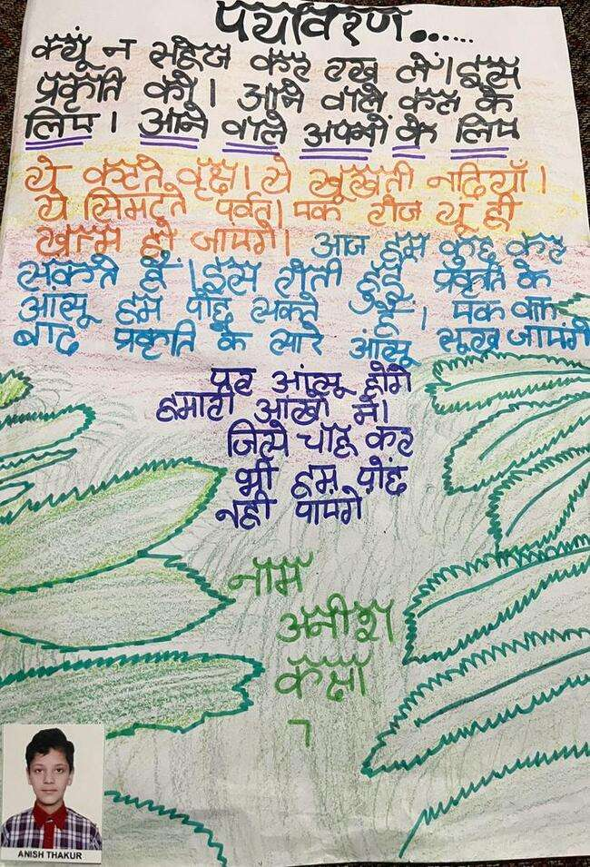

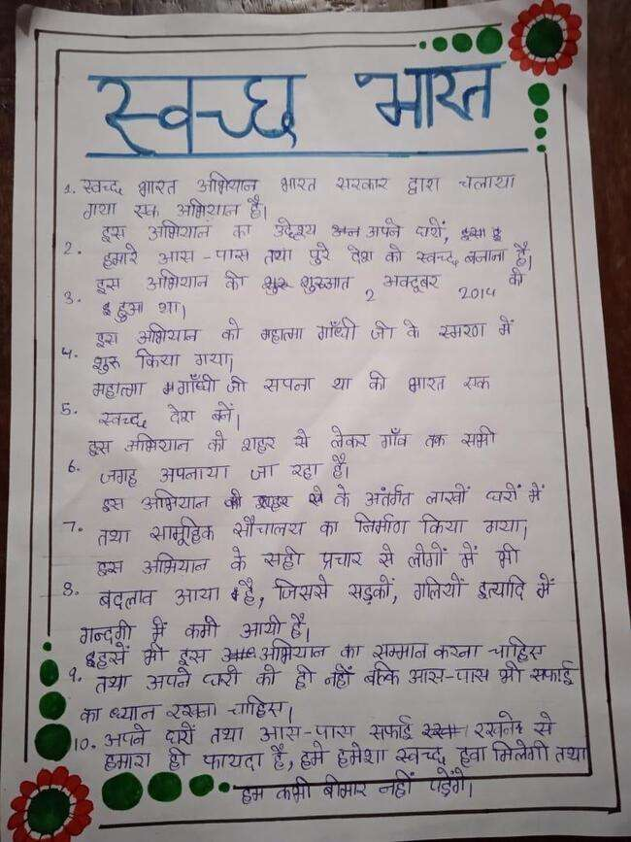
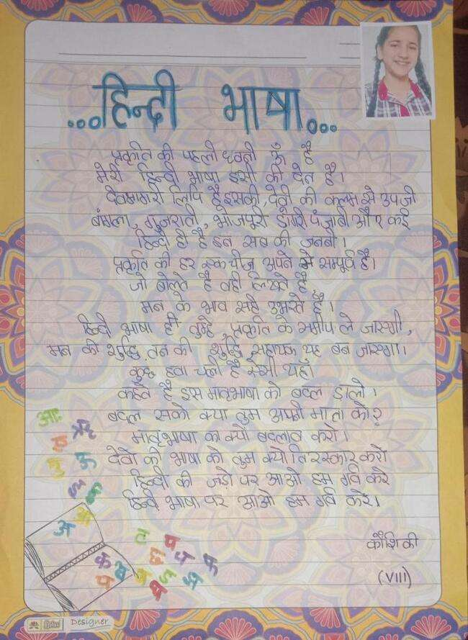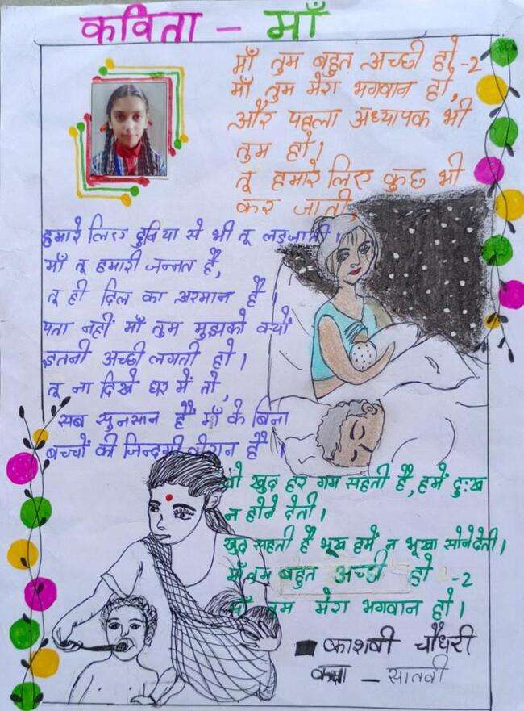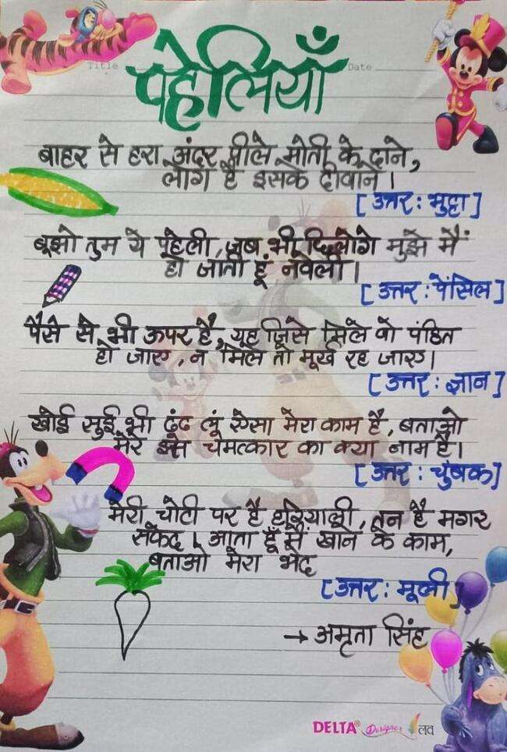

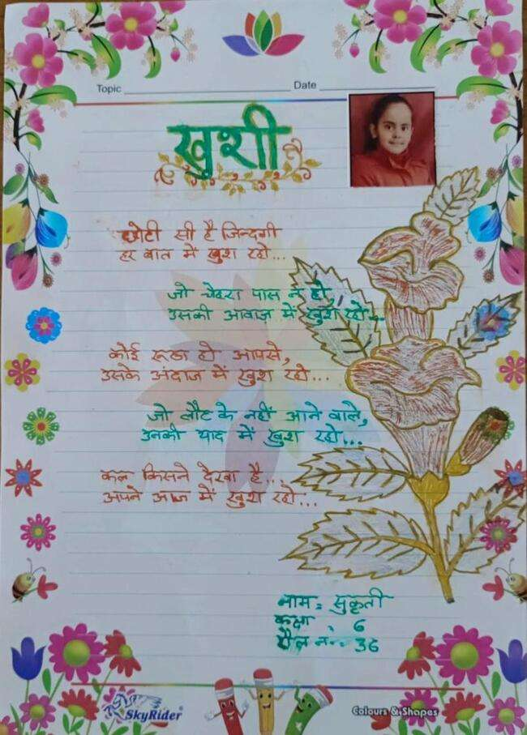

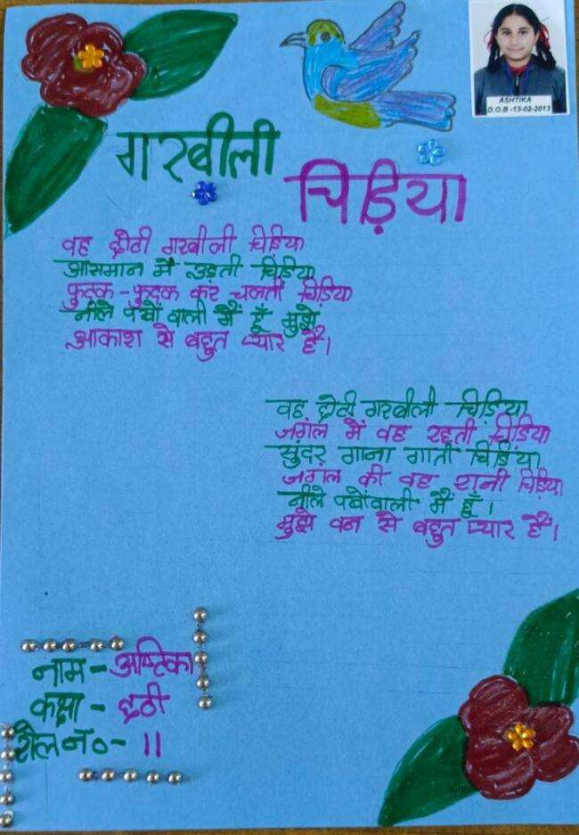

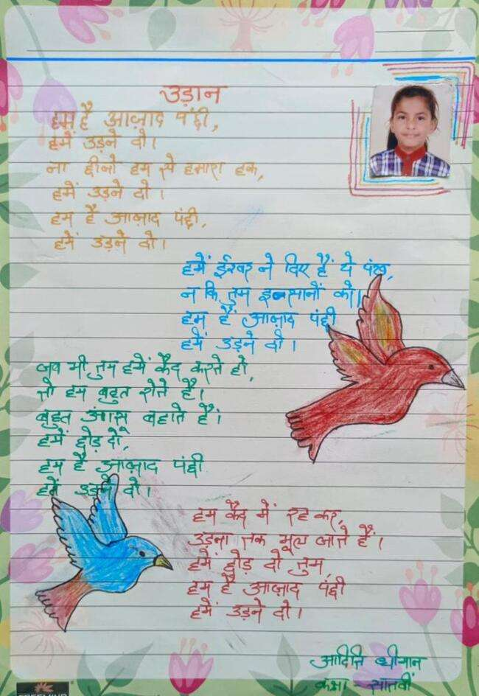

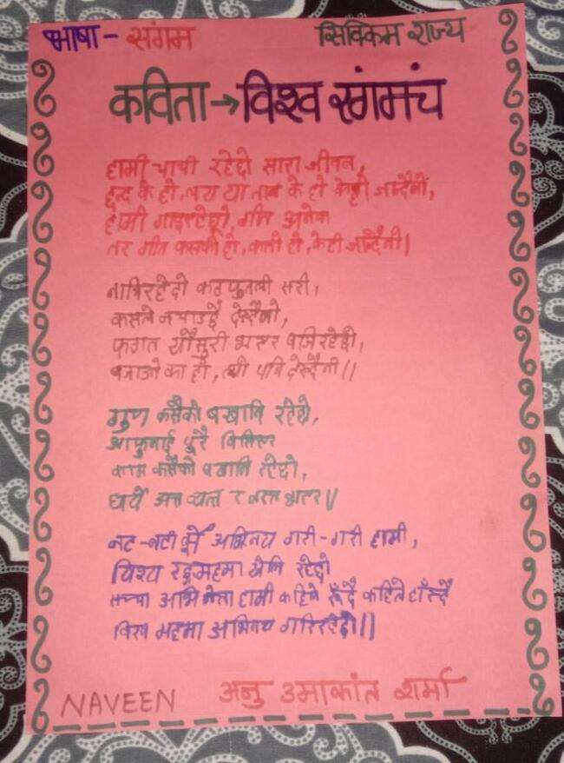

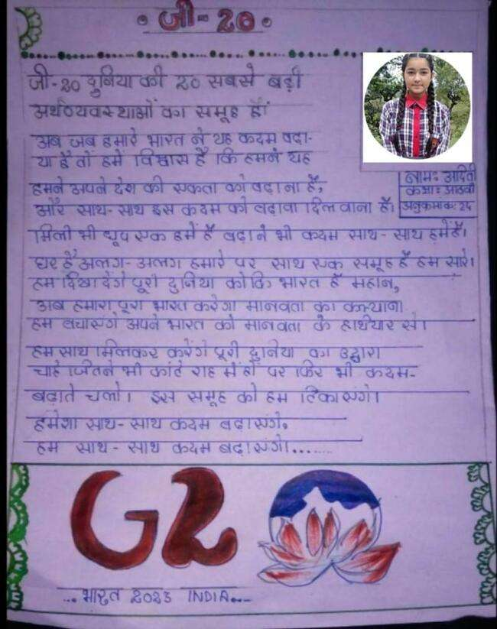

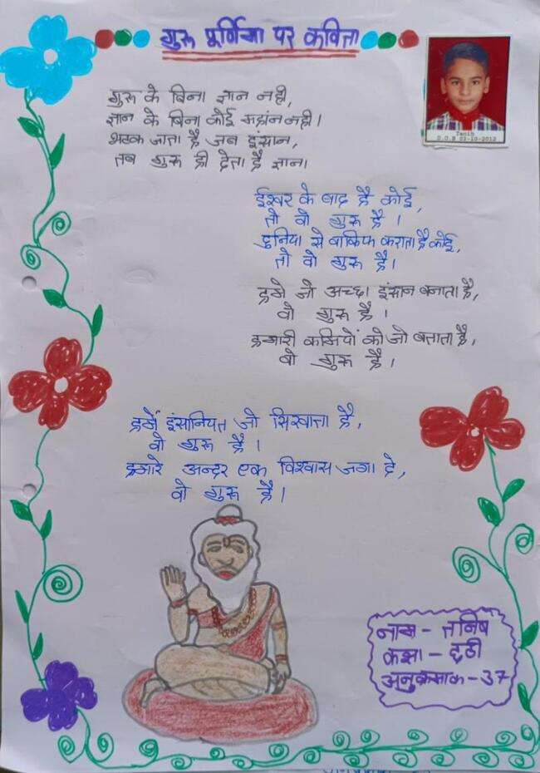

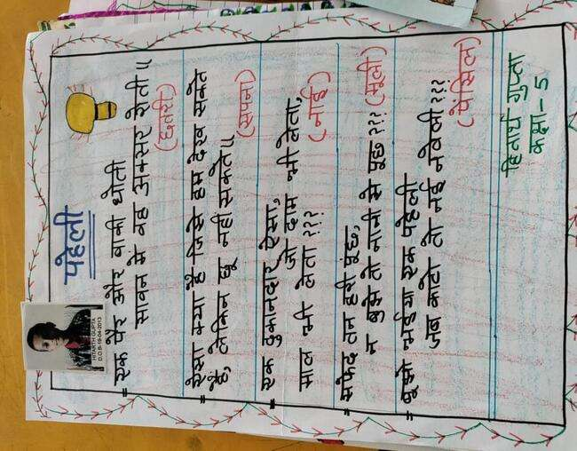

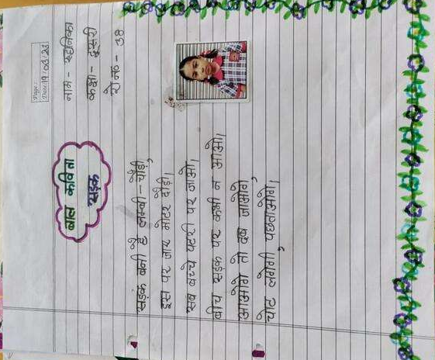

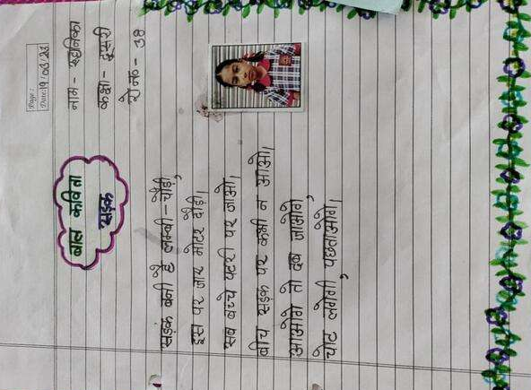

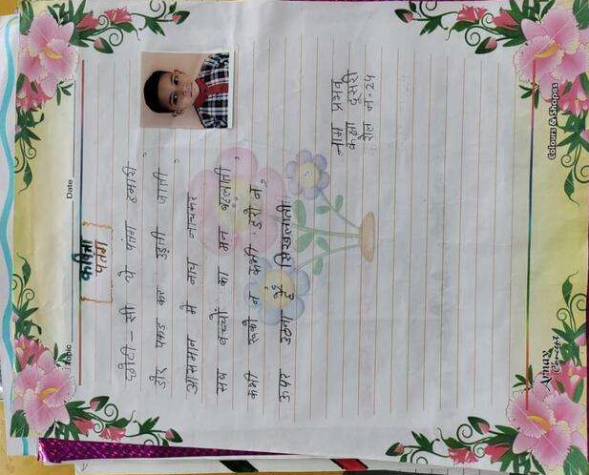

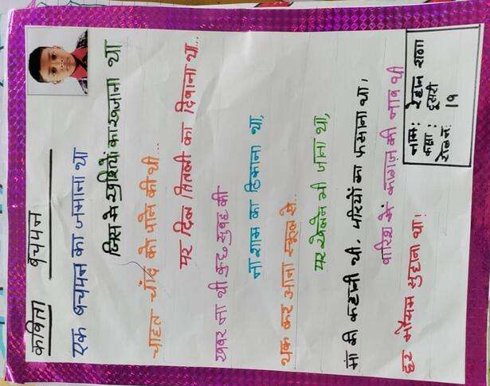

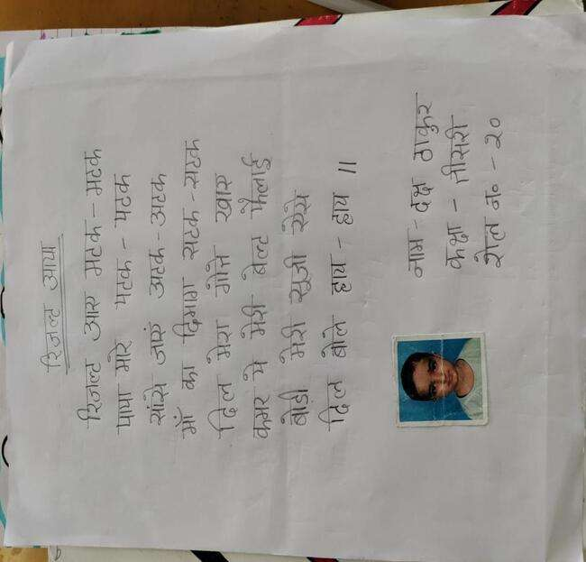

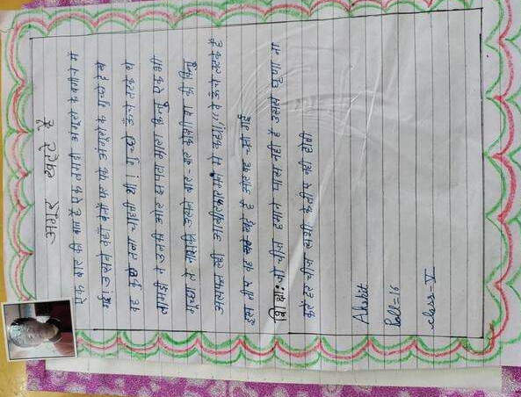
संस्कृत विभाग
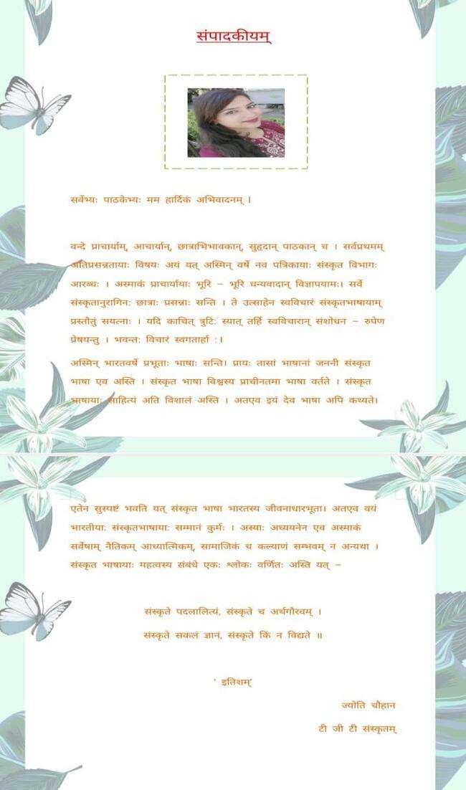
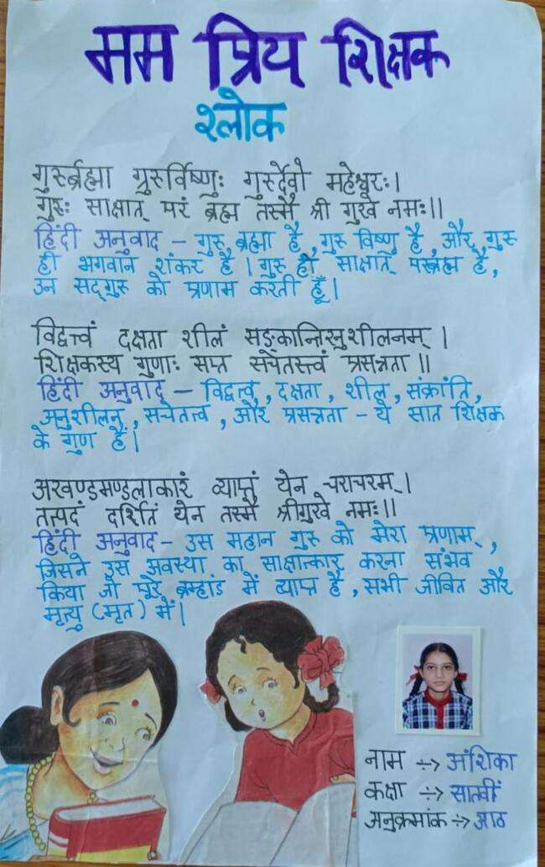
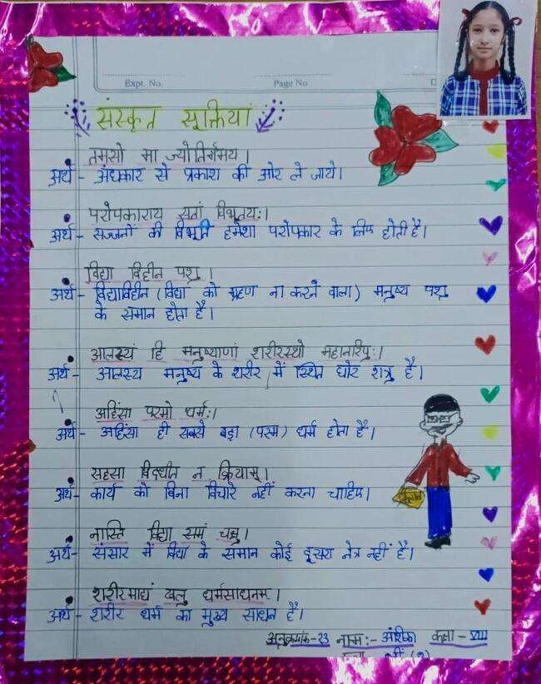

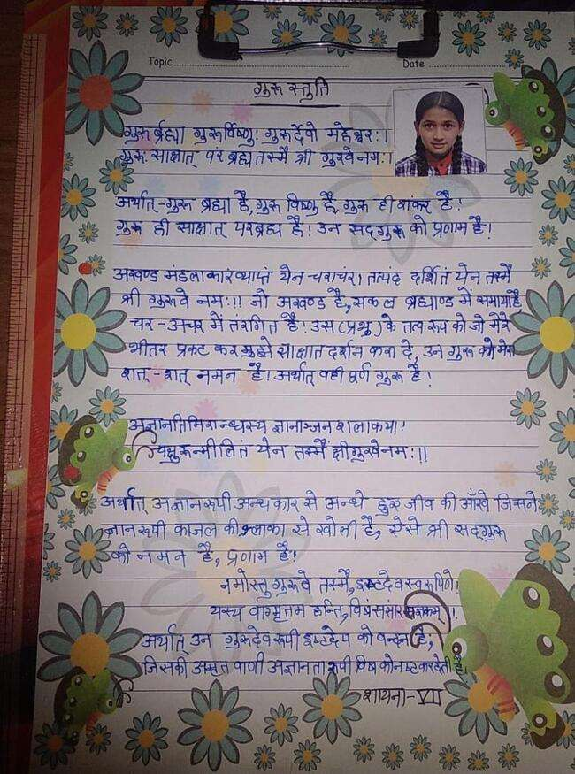
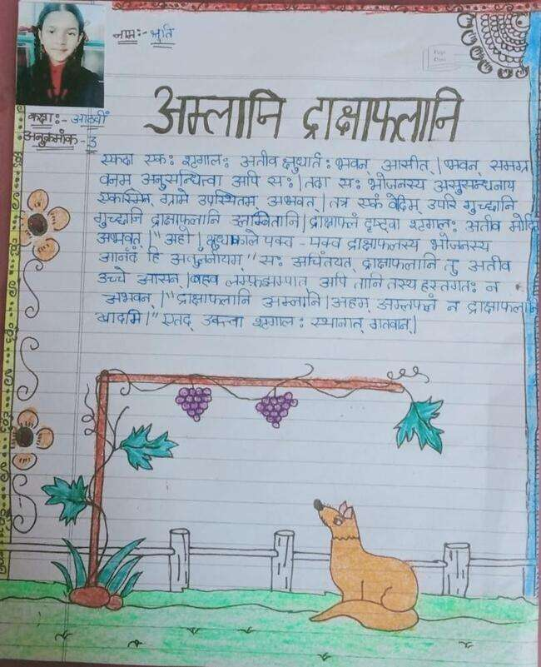

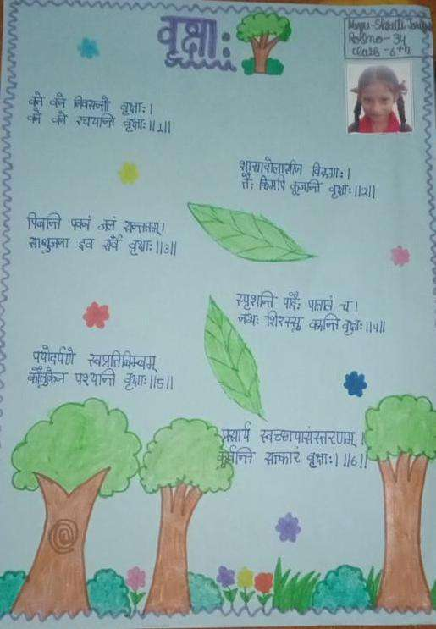

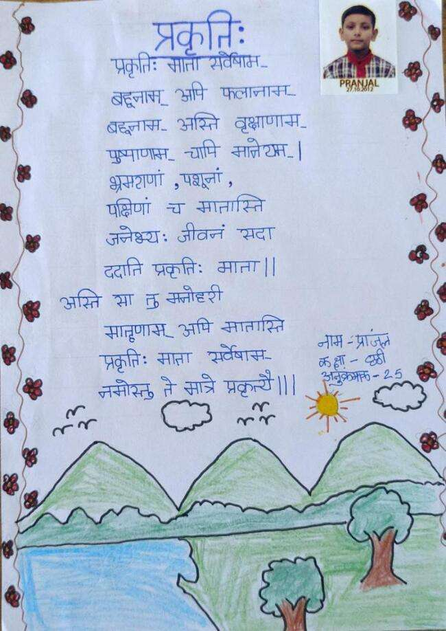
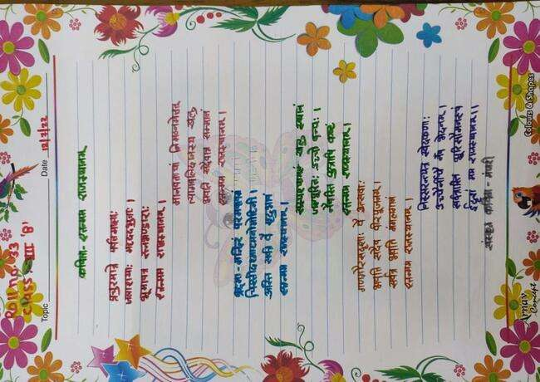

ENGLISH CORNER

Dear All,

Watching how K V Dharamshala Cantt. has succeeded in redefining educational limits over the past few years is fascinating.

Martin Luther once remarked, "Pick up your pen and write if you want to change the world." I'm excited to be a member of the editorial team and to see the variety of skills that KV Dharmshala Cantt faculty and students have. The fact that there are so many different people, ideas, and viewpoints makes me reflect on how diverse we all are yet still manage to express ourselves to the best of our abilities.

Join in on this adventure, and I sincerely hope you enjoy reading our magazine!
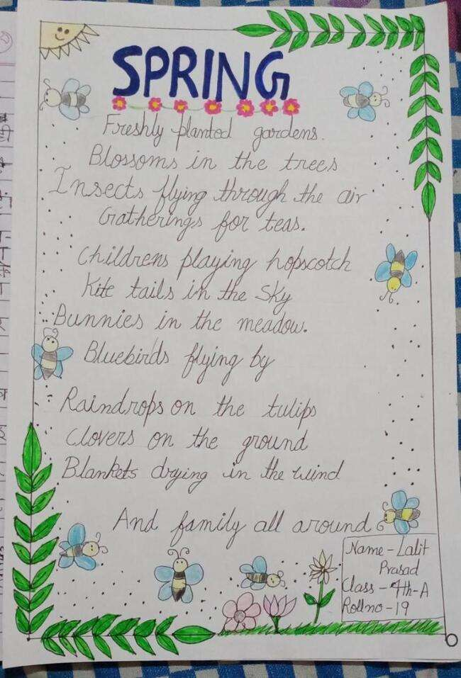

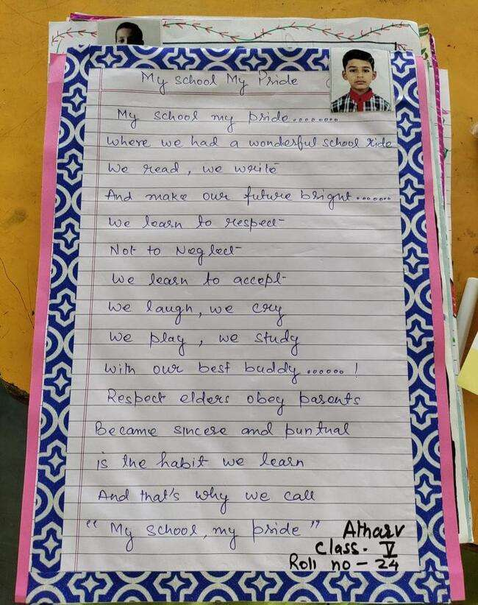
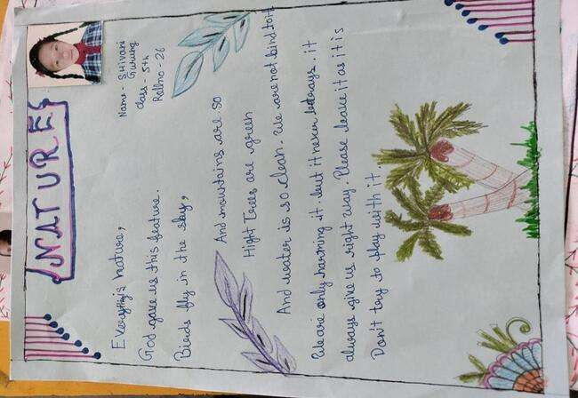

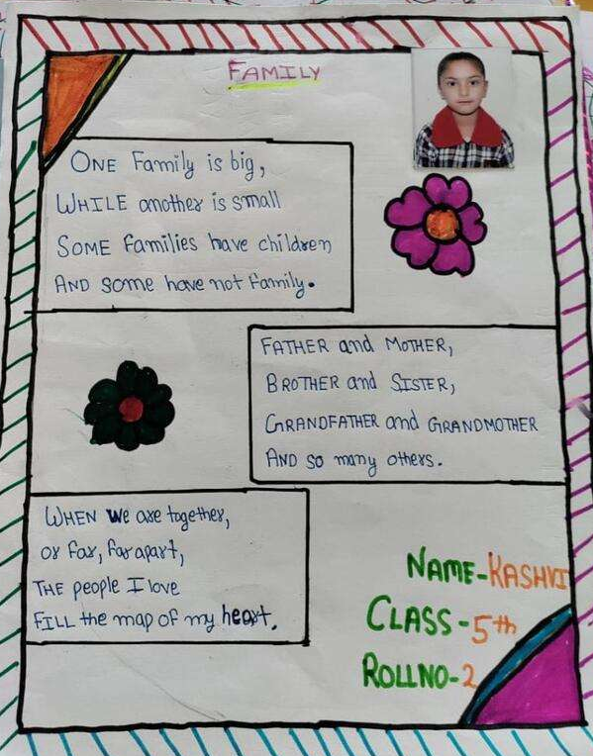

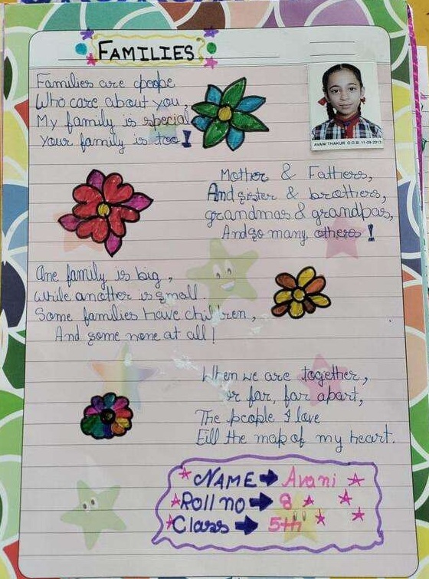

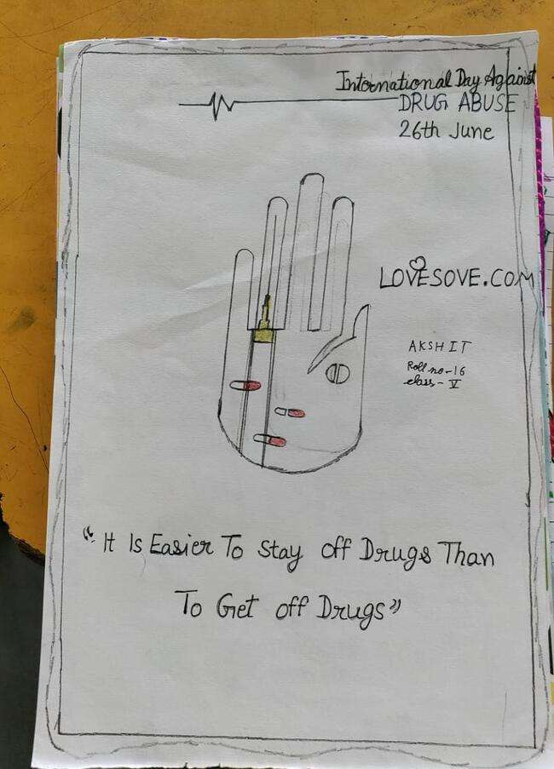

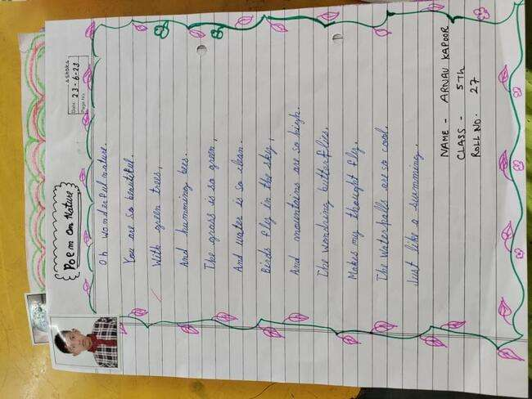

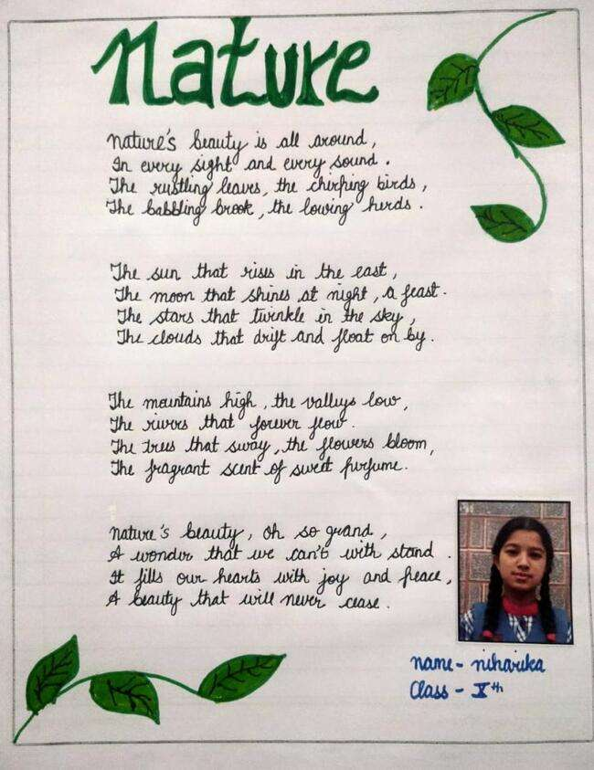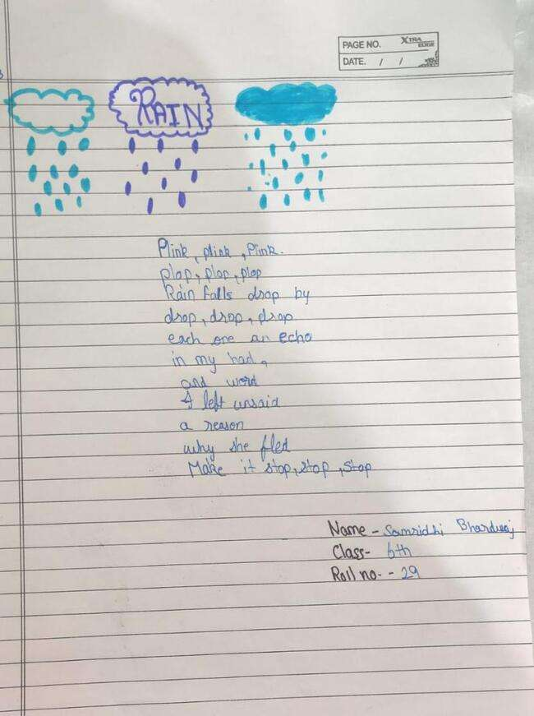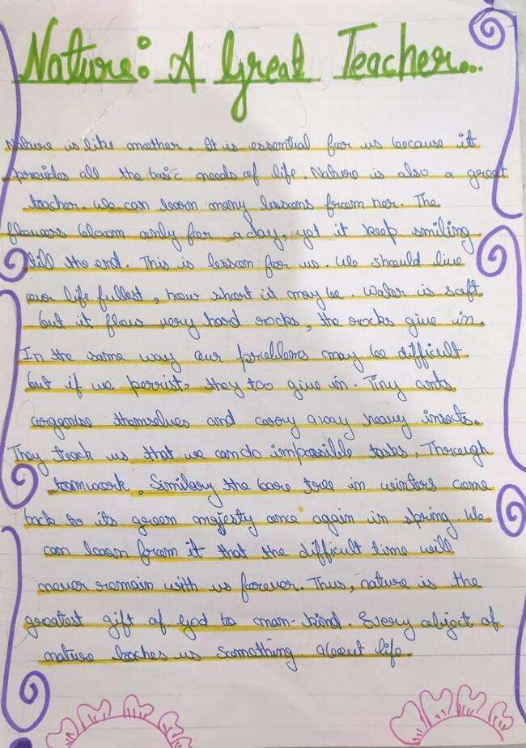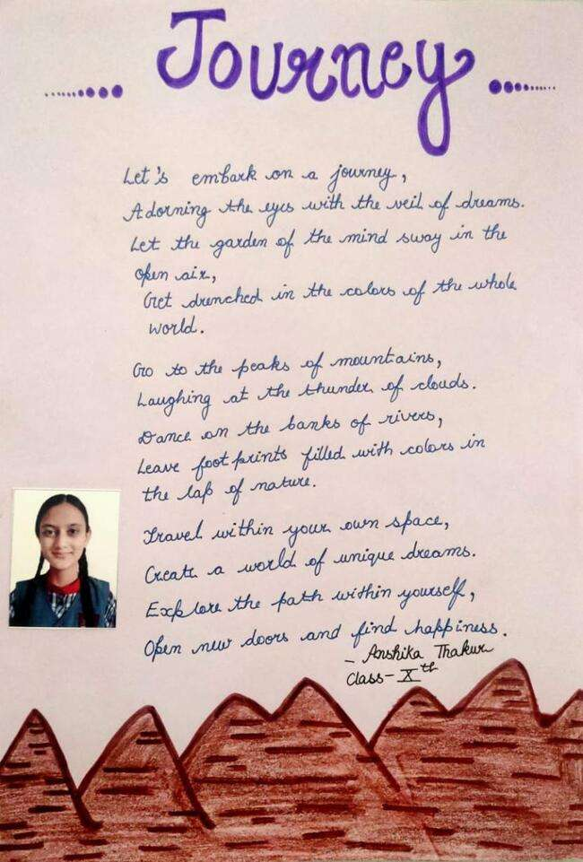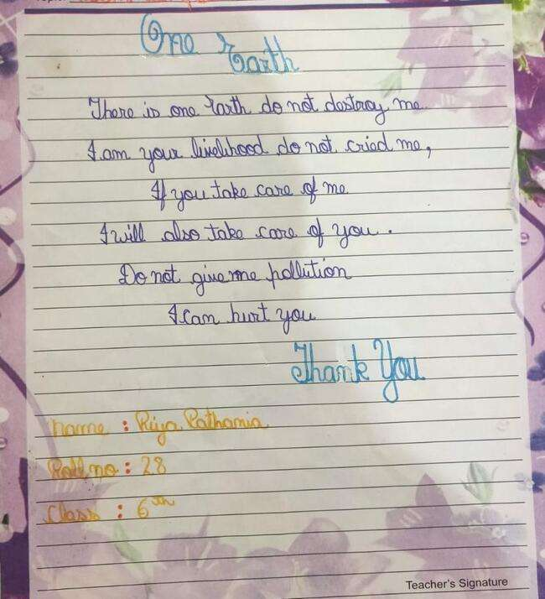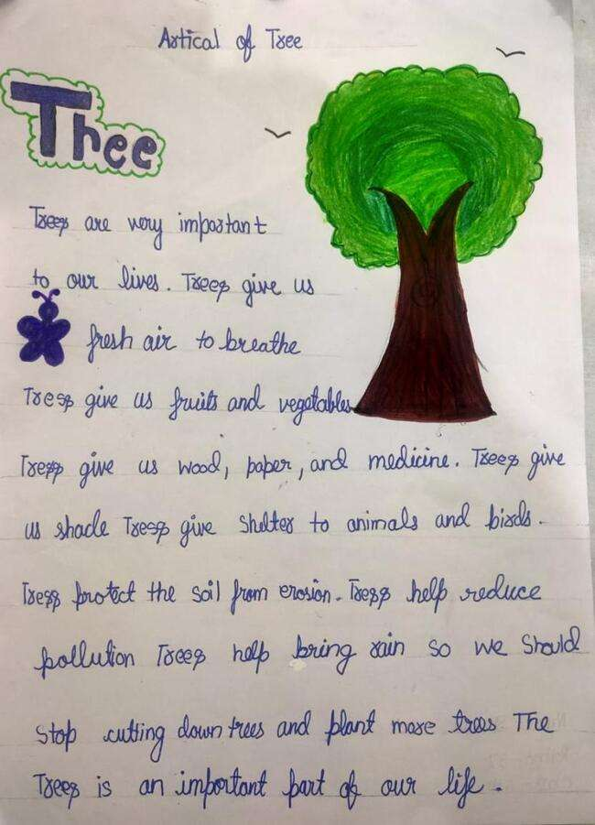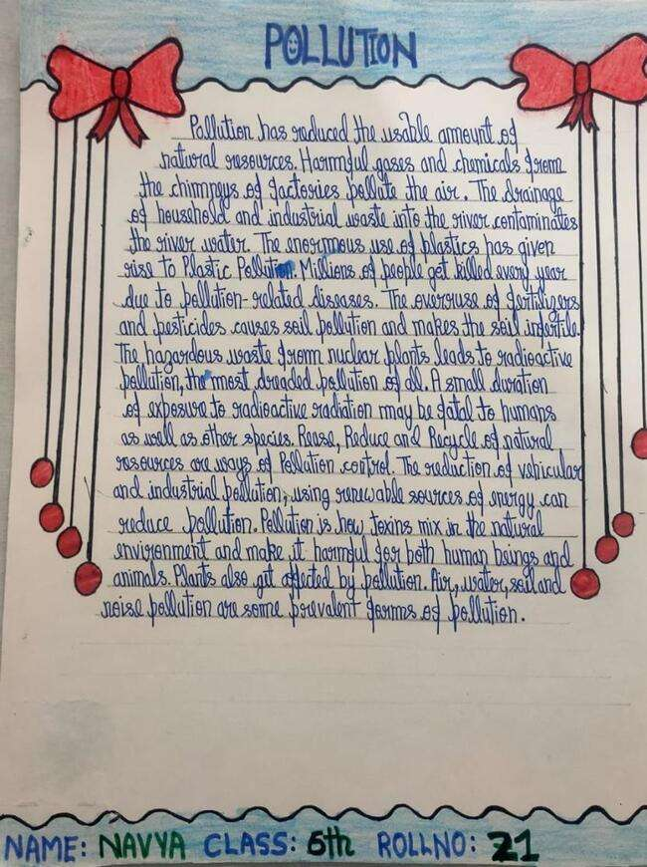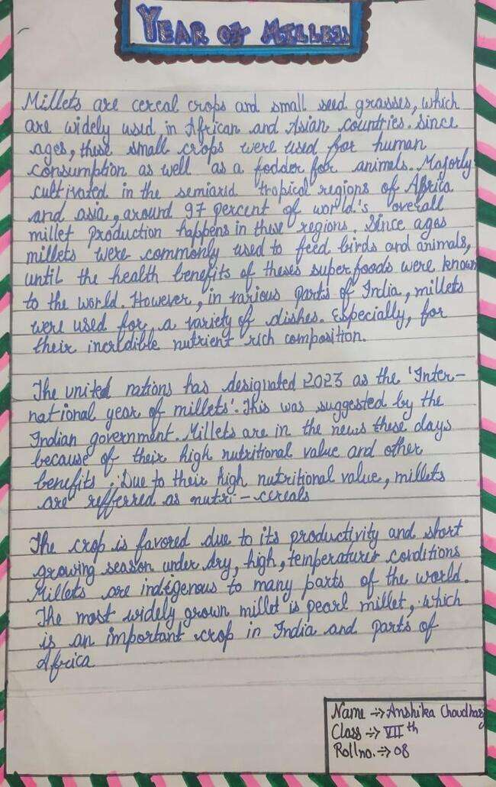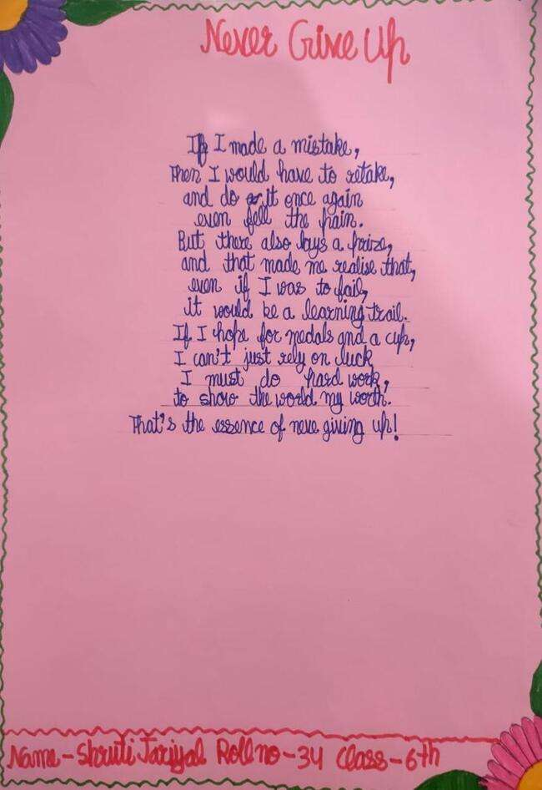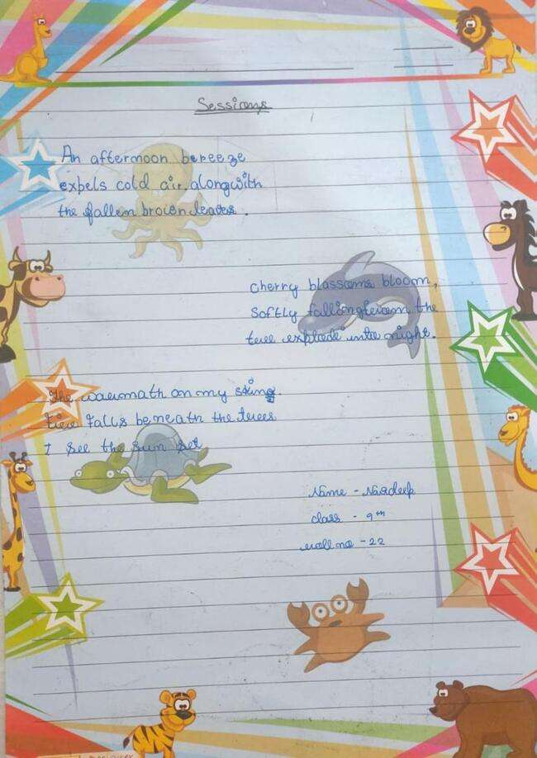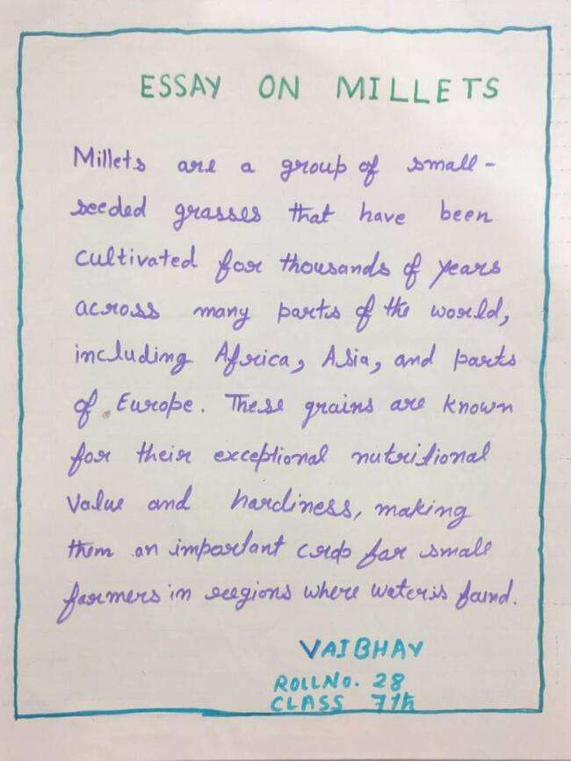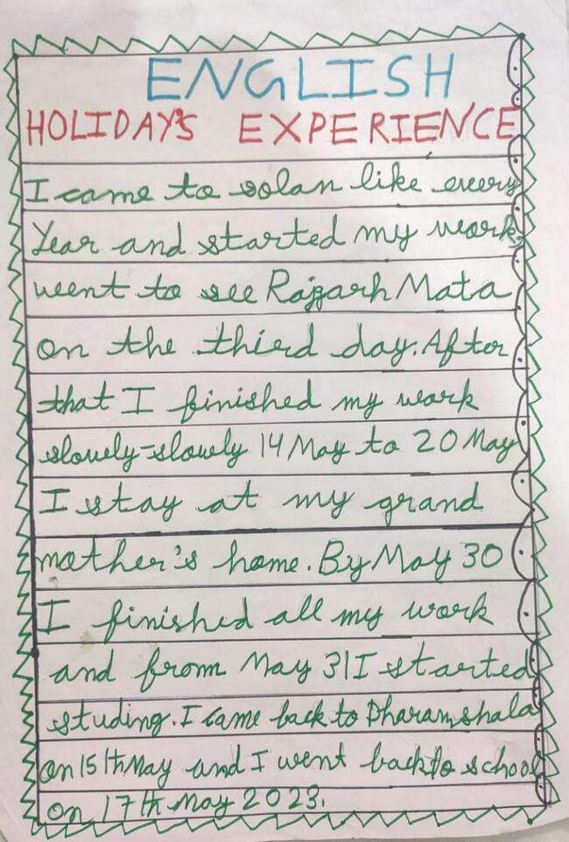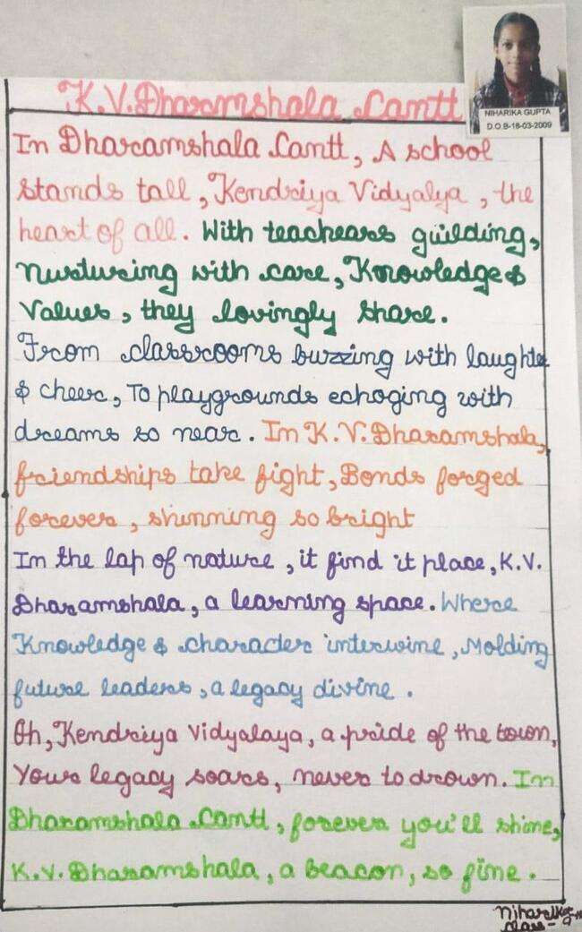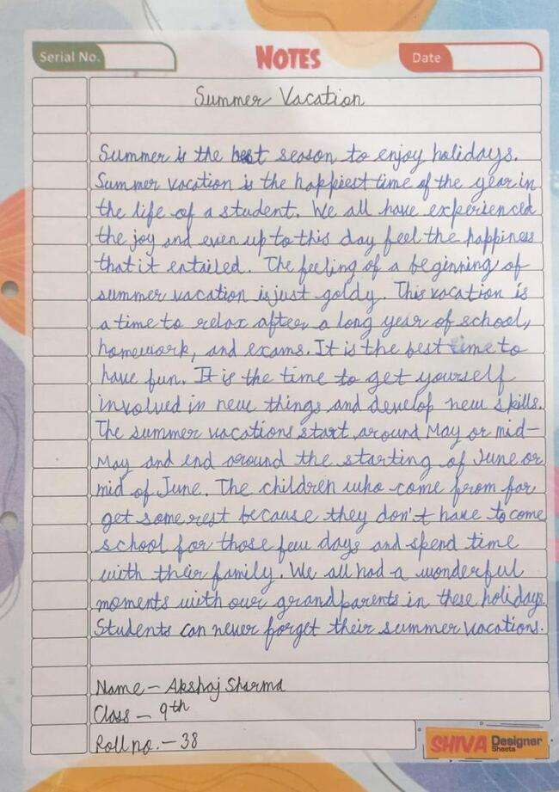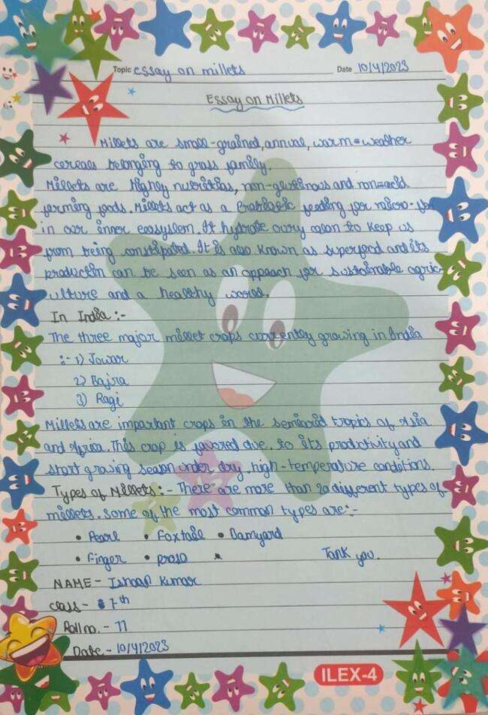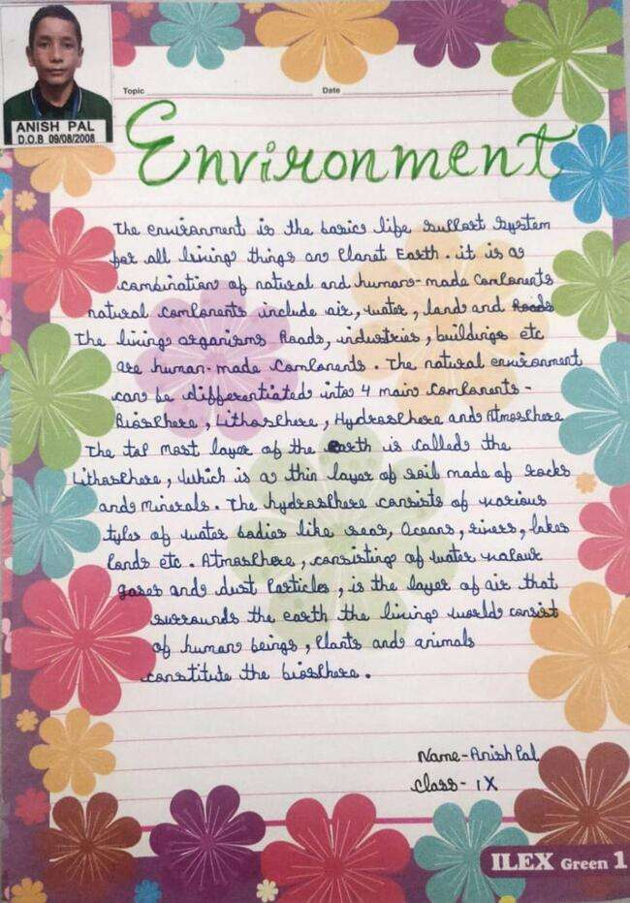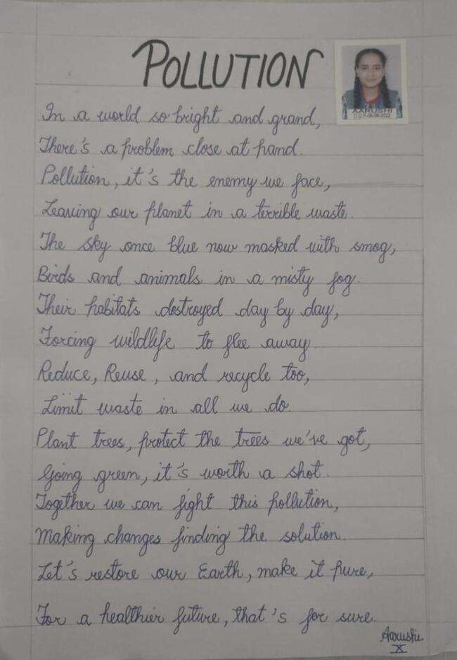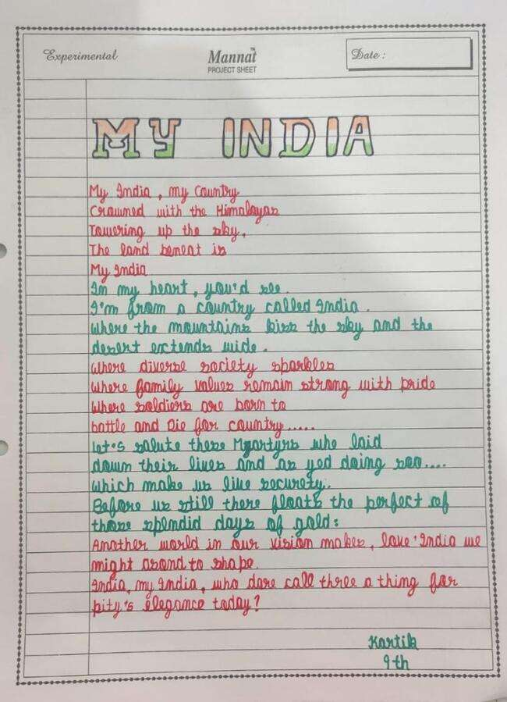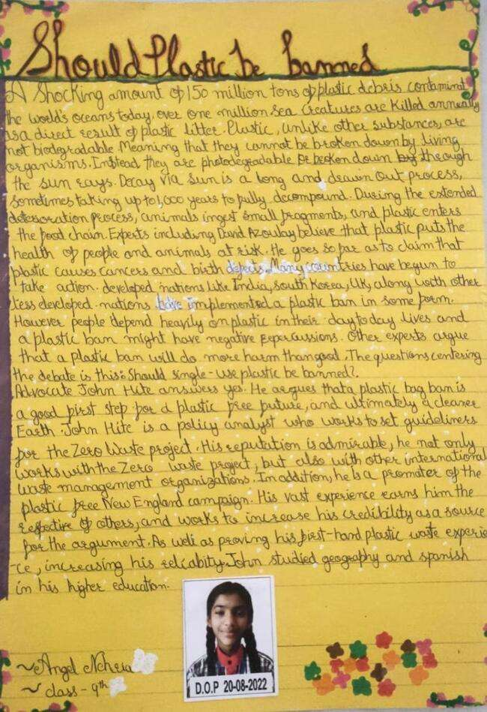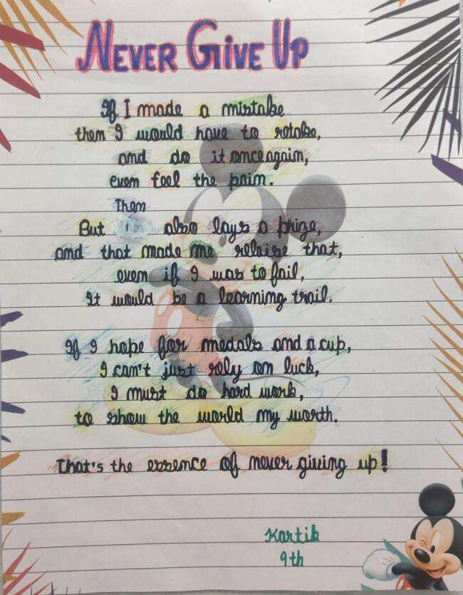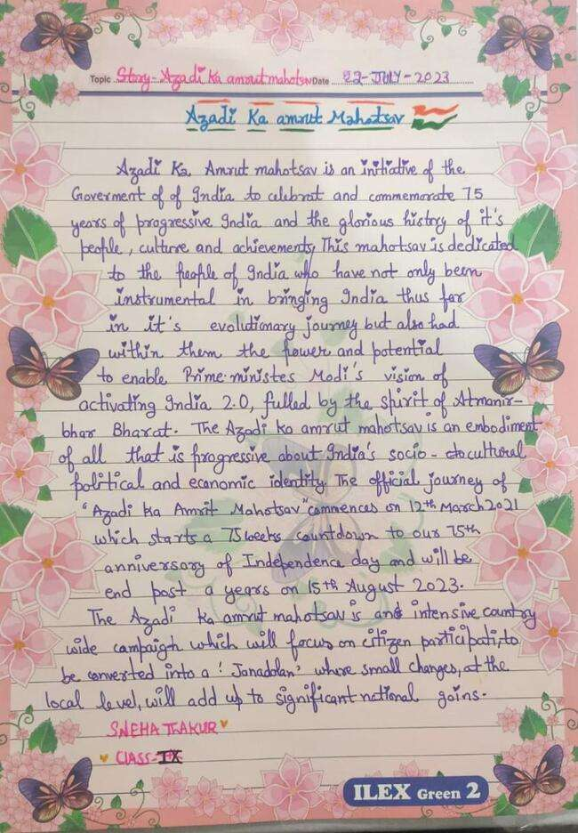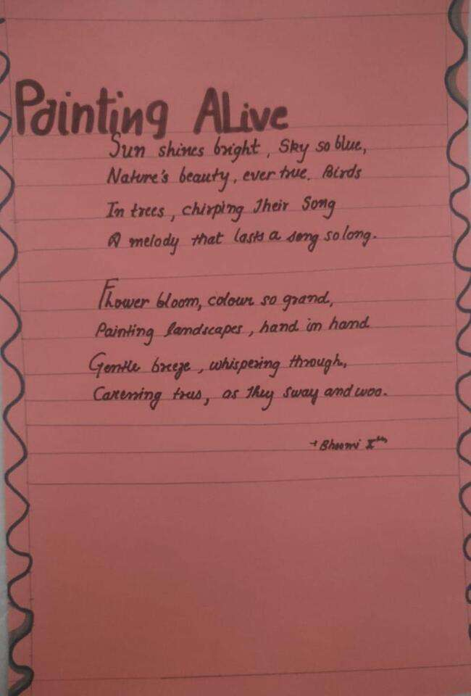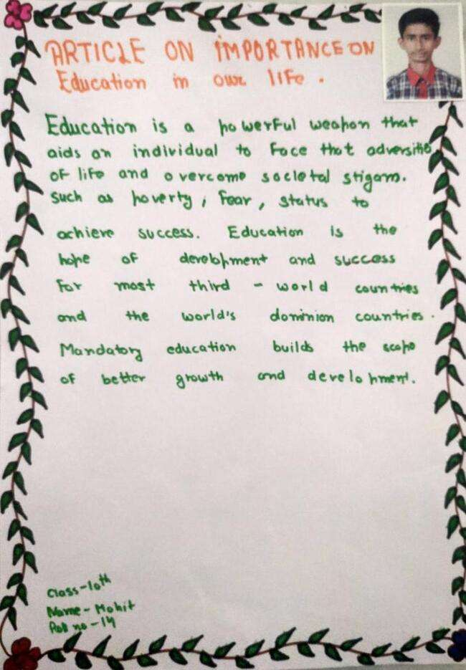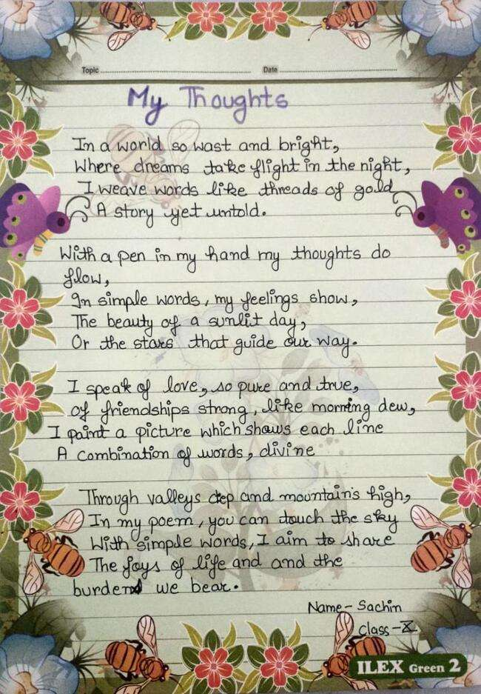

CREATIVE CORNER

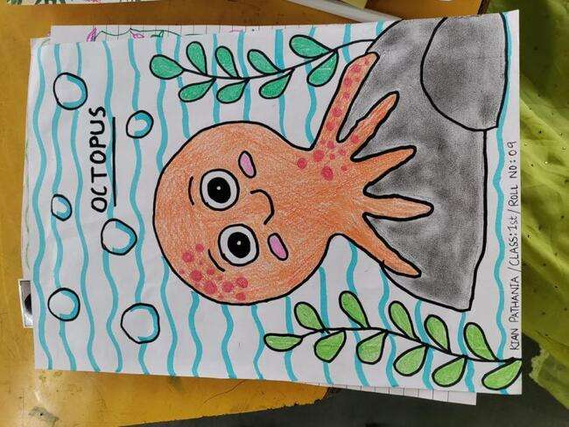

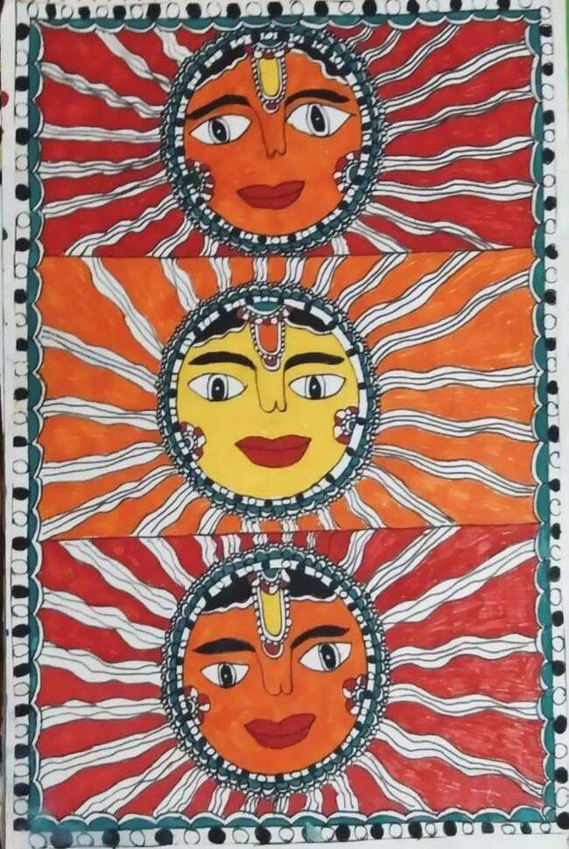

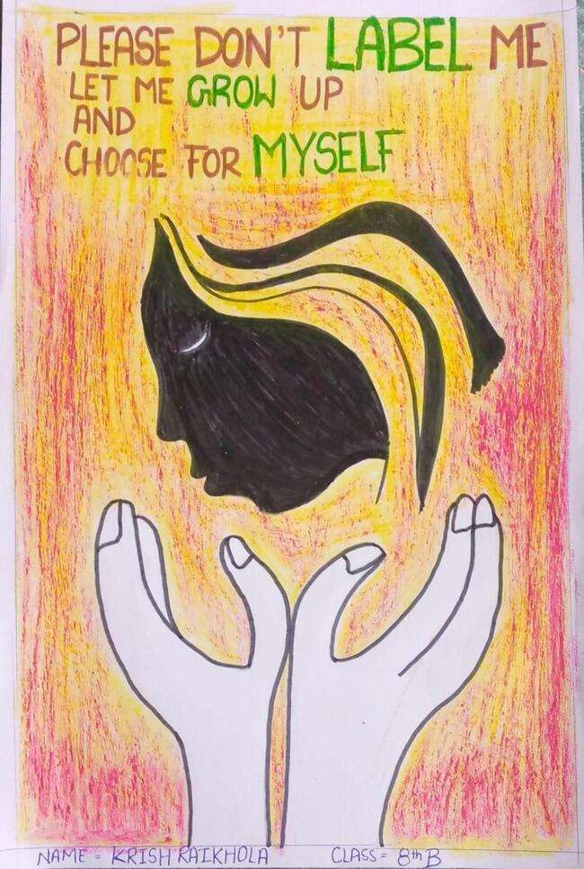
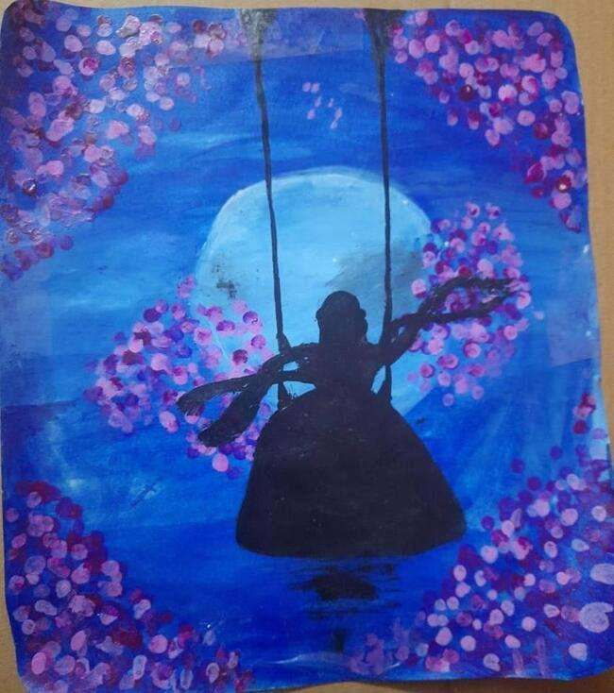
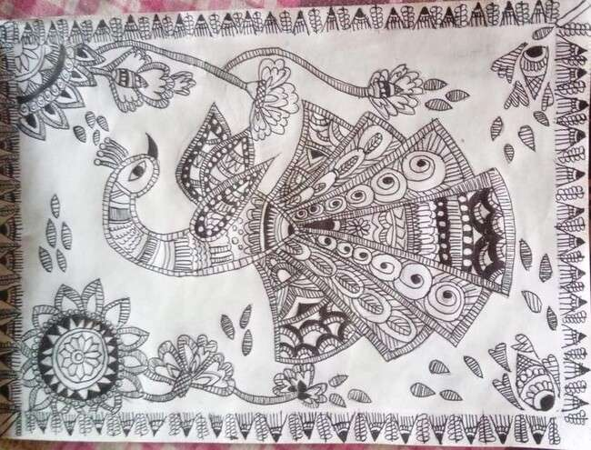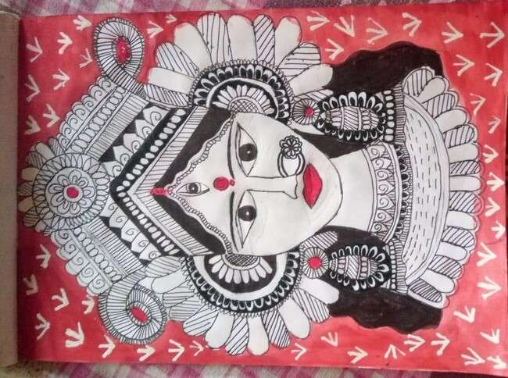
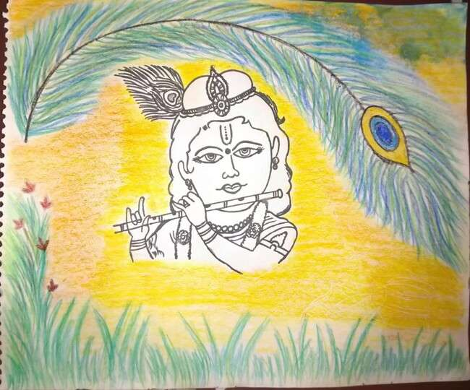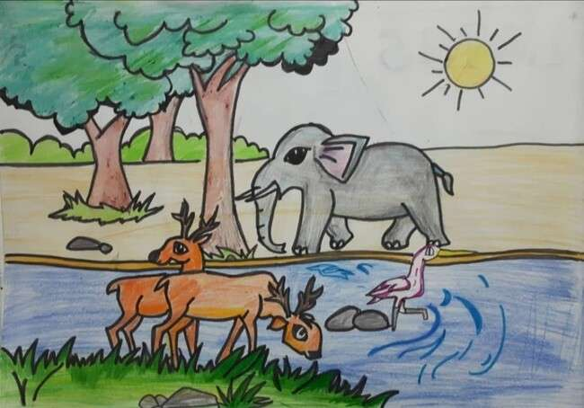
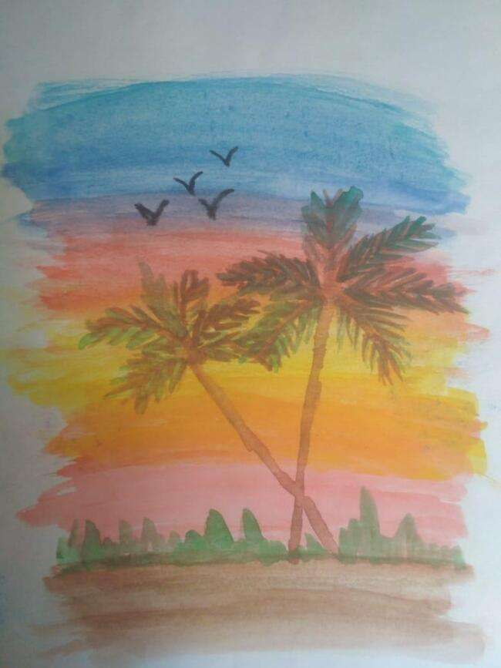
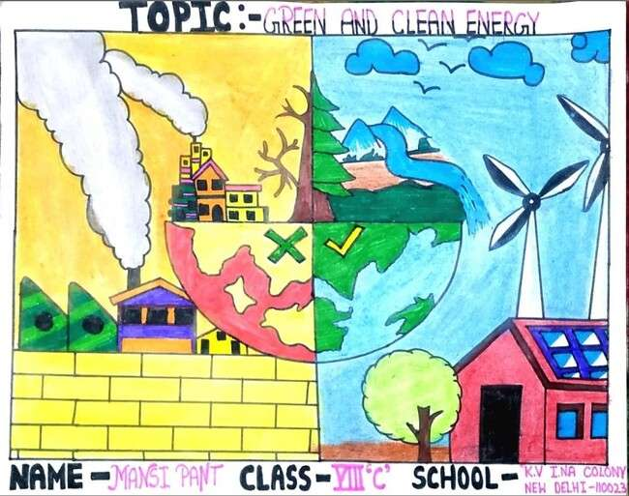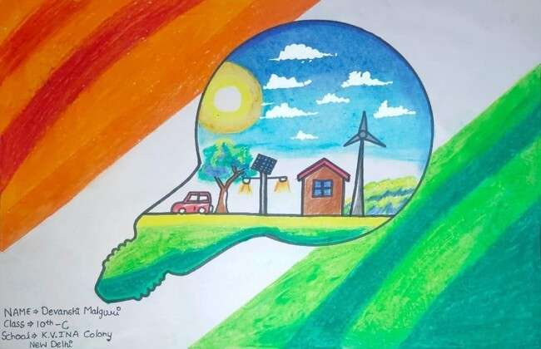
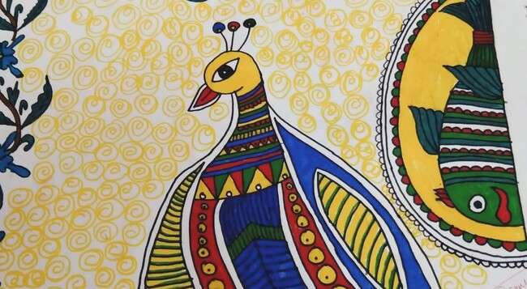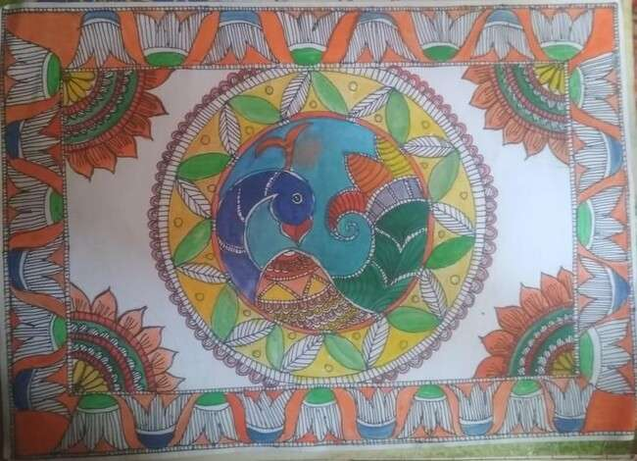
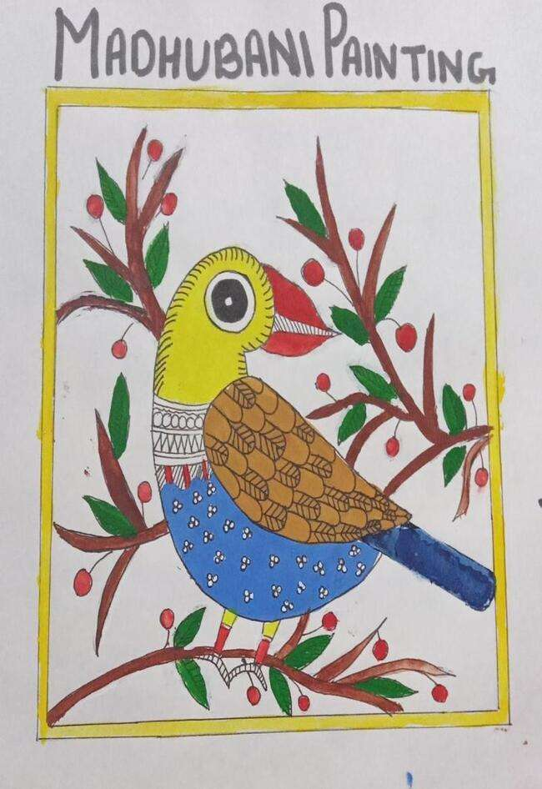
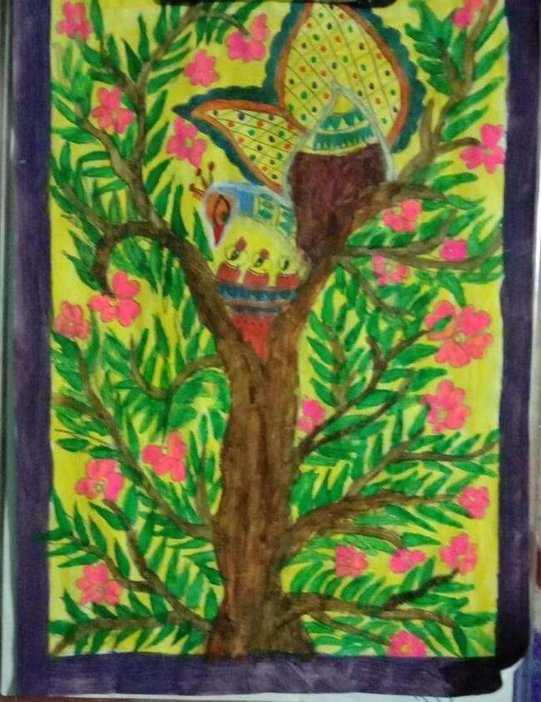

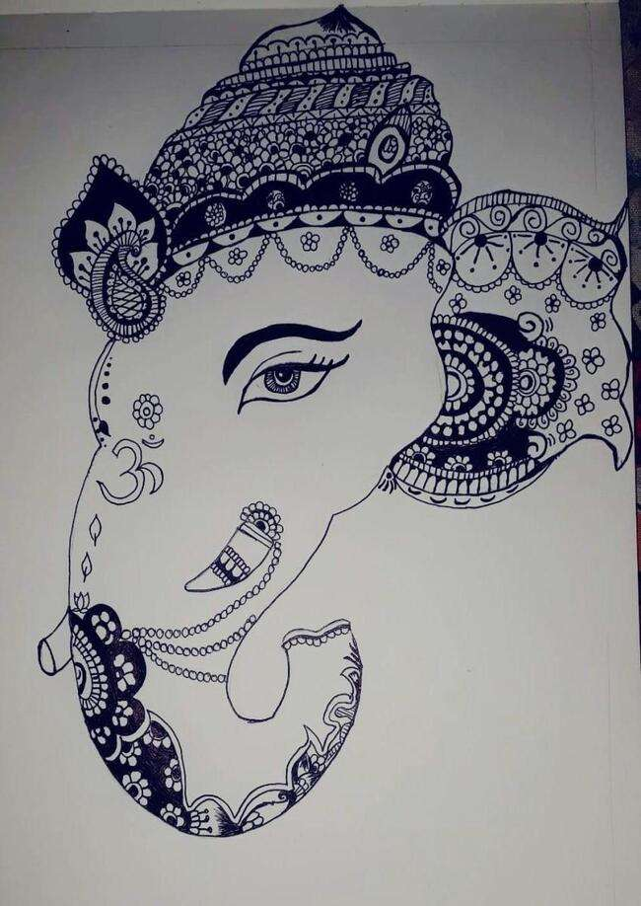

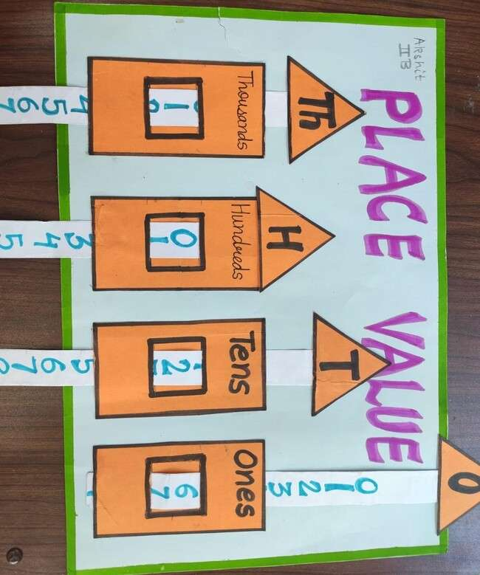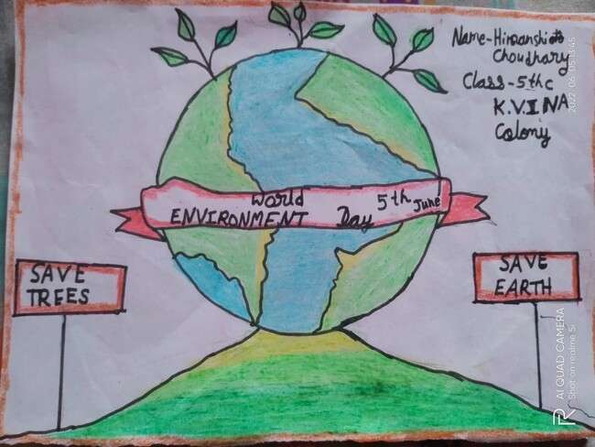

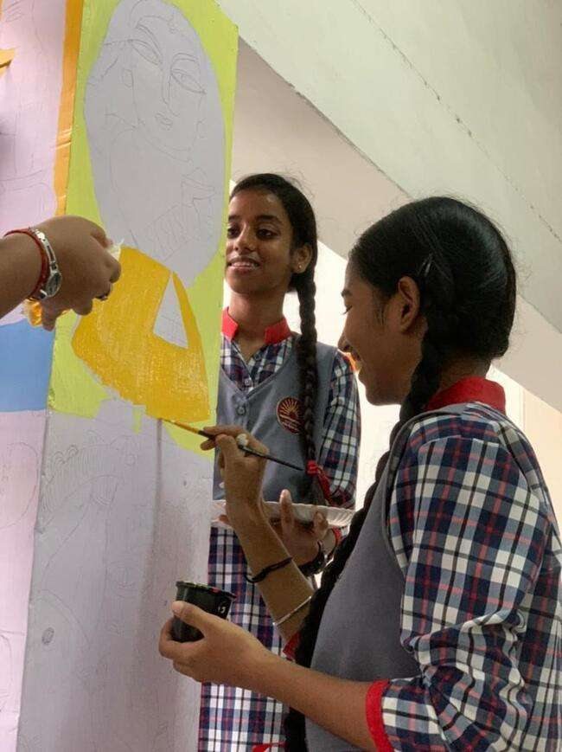
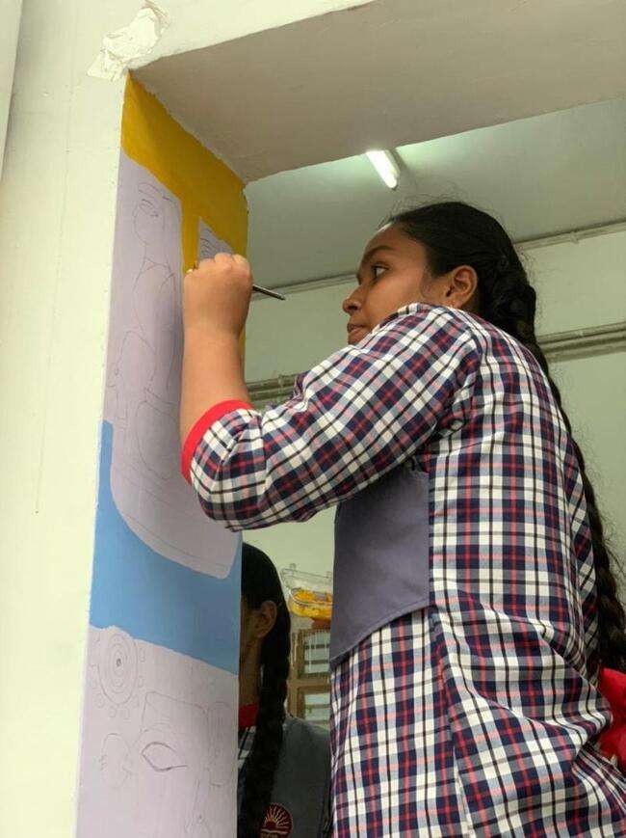
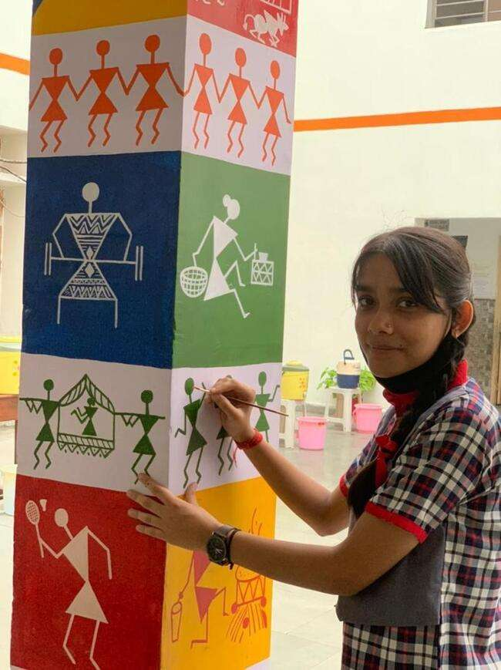
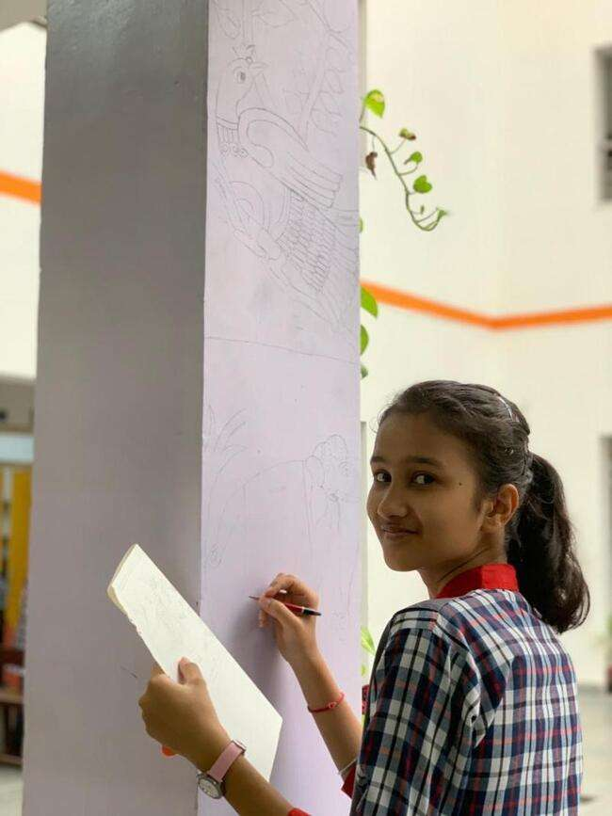

र्न्यर्ाद

